Moduldokumentation

Modul Applikationssicherheit (apsi)

Simon Wächter

2019

Inhalt

1 Einleitung 6

1.1 Einleitung 6

1.2 Lernziele 6

1.3 Prüfungen 6

2 Woche 1 7

2.1 Agenda 7

2.2 Administrative Issues 7

2.3 Who is Your Lecturer (Wagner) 7

2.4 whoami (Schläpfer) 8

2.5 Why is Application Security Important? 8

2.6 Lecture Overview (1) 9

2.7 Lecture Overview (2) 9

2.8 Lecture Overview (3) 10

2.9 Example: Buffer Overflow 10

2.10 How does a Buffer Overflow Work? 10

2.11 Buffer Overflow Demo 11

2.12 Not Really a Fix for Buffer Overflow: Stack Protection 11

2.13 Fix for Buffer Overflow: Checked Buffers 11

2.14 Example: Taint Checking in Perl (1) 12

2.15 Example: Taint Checking (2) 12

2.16 Example: Taint Checking (3) 13

2.17 Example: Taint Checking (4) 13

2.18 Example: Data Leakage by Behavior (1) 13

2.19 Example: Data Leakage by Behavior (2) 14

2.20 Example: Data Leakage by Error Output 14

2.21 Human Factors 15

2.22 Exercises and Preparation for Next Week 15

2.23 Reserve 15

3 Woche 2 16

3.1 Agenda 16

3.2 Recap: What do Attackers Want? 16

3.3 Buffer Overflow II 16

3.4 Buffer Overflow II 17

3.5 Buffer Overflow II 17

3.6 Buffer Overflow II 18

3.7 Buffer Overflow II 18

3.8 Attack Technique: Fuzzing 19

3.9 Error Handling 19

3.10 Case study – Handling too long input 20

3.11 Case-study: Compression Bomb 20

3.12 Error Handling 21

3.13 Algorithmic Complexity Attacks 22

3.14 Algorithmic Complexity: Sorting 22

3.15 Algorithmic Complexity: Hashing 23

3.16 Algorithmic Complexity: Regular Expressions 23

4 Woche 3 24

4.1 Agenda 24

4.2 Secure Coding Principle: Test-before-use 24

4.3 Input Validation 24

4.4 Input Normalization 25

4.5 Unix Permission Model (simplified) 25

4.6 Chroot 26

4.7 Mandatory Access Control (MAC) 26

4.8 MAC Example: SELinux 27

4.9 MAC Example: AppArmor 27

4.10 Secure Coding Principle: Defense in Depth 28

4.11 Privilege Separation 28

4.12 Overall Idea 29

4.13 Form of the Modules 29

4.14 Example: OpenSSH 30

4.15 OpenSSH: Privilege Separation Approach 30

4.16 Example: Postfix MTA (Email Server) 30

4.17 Postfix System View 31

4.18 Postfix: Example Data-Flow 31

5 Woche 4 32

5.1 Agenda 32

5.2 Security Testing (for Software) 32

5.3 Pen-Test 32

5.4 How does a Pen-Test fail? 33

5.5 Code Inspection and Review 33

5.6 Code Scanners 34

5.7 Execution Emulators 34

5.8 Patching 35

5.9 How to Patch 35

5.10 Problems with Patching 36

5.11 Problems with not Patching 36

5.12 Problems with Unavailability of Patches 36

5.13 Economic Aspects of Security 37

5.14 Case Study: DDoS on Brian Krebs (20.9.2016) 37

5.15 What can Perform Such an Attack? 37

5.16 IoT: Internet of insecure Things 38

5.17 Why are These IoT Devices so Insecure? 38

5.18 Possible Solutions 39

5.19 Does it Pay to make Software Secure? 39

5.20 So, what to do? 40

6 Woche 5 41

6.1 Agenda 41

6.2 Generating Cryptographic Keys 41

6.3 Information-Theoretical Entropy 42

6.4 Estimating Entropy is Tricky 42

6.5 Seeding a CPRNG 43

6.6 Bad Seeding Examples 43

6.7 Storing Cryptographic Keys Securely 43

6.8 Storing Passwords 44

6.9 Rainbow Table 44

6.10 Storing Passwords 45

6.11 So What is Wrong with PBKDF2? 45

6.12 Hardware RNGs 46

6.13 Example 1: Via C3 Hardware CPRNG Schematic 46

6.14 Example 2: Intel RDRAND Schematic 47

6.15 Compromise on Design-Level 47

6.16 Storing Private Data (as a Service Provider) 48

6.17 Disk/Storage Encryption 48

6.18 Disk Encryption Protects Against What? 48

6.19 Decryption Only With User Logged In 49

6.20 Encryption in the Cloud 49

6.21 JavaScript Client-Side Encryption in Web-Apps 50

7 Woche 6 51

7.1 Agenda 51

7.2 Virtualization vs. Security 51

7.3 DoS on Application Layer 52

7.4 DoS on Application Layer 52

7.5 Code Analysis for Security 53

7.6 Backdoors in Code 53

7.7 Backdoor Hiding Techniques 54

7.8 Finding Backdoors 54

7.9 Backdoors in Cryptography 55

7.10 Example 1: ECC 55

7.11 Example 2: Specially selected Primes for Discreet Logarithms 56

7.12 Fuzz-Testing: The Idea 56

7.13 Possibilities and Limitations 57

7.14 Structured Fuzzing vs. Random Fuzzing 57

7.15 Fuzzing for Regular Tests 58

7.16 Useful Fuzzing Tools 58

8 Woche 7 59

8.1 Agenda 59

8.2 Example Request in the TCP/IP Model 59

8.3 HTTP 59

8.4 HTTP Request Example: GET 60

8.5 HTTP Request Example: POST 60

8.6 HTTP Response Example 61

8.7 Exotic Requests: PUT, DELETE, ... 61

8.8 HTTP Authentication 62

8.9 HTTP Authentication 62

8.10 Cookies 63

8.11 Cookie Options 63

8.12 Cookies: Access via JavaScript 64

8.13 Session Management 64

8.14 Security Problems with Session Management 65

8.15 Keeping State Securely on Client-Side 65

8.16 Remark: Cookies and Application Paths vs. Proxies 66

8.17 SSL/TLS 66

8.18 SSL/TLS 67

8.19 CGI: General Idea 67

8.20 CGI Scripts in Different Languages 68

8.21 CGI in BASH 69

8.22 CGI in BASH: Output 69

8.23 CGI in Perl 70

8.24 CGI in Perl: Output 70

8.25 CGI in C 71

8.26 CGI in C: Output 71

8.27 CGI in Java 72

8.28 CGI Security 72

9 Woche 8 73

# Einleitung

## Einleitung

Dieses Dokument stellt die Moduldokumentation für das Modul apsi dar. Allfällige Unterlagen sind im Modulordner zu finden.

## Lernziele

Das Modul beinhaltet folgende Lernziele:

* Kennen typische Bedrohungen von Applikationen sowie ihren Daten und können abschätzen, wieweit diese für durch sie zu entwickelnde Software ein Sicherheitsrisiko darstellen
* Kennen typische Sicherheitsprobleme und können sie vermeiden
* Sind in der Lage, einschlägige Quellen zu konsultieren, um neu veröffentlichte Sicherheitsprobleme zu erfassen und zu verstehen, wie diese zu vermeiden sind
* Verfügen über Konzeptwissen, nicht nur Produktwissen, um das Gelernte auch in anderen Umfeldern und mit anderen Programmiersprachen anwenden zu können

## Prüfungen

Die Modulnote setzt sich zu 100% aus einer Semesterprüfung und einer Modulschlussprüfung zu je 50% zusammen.

# Woche 1

## Agenda

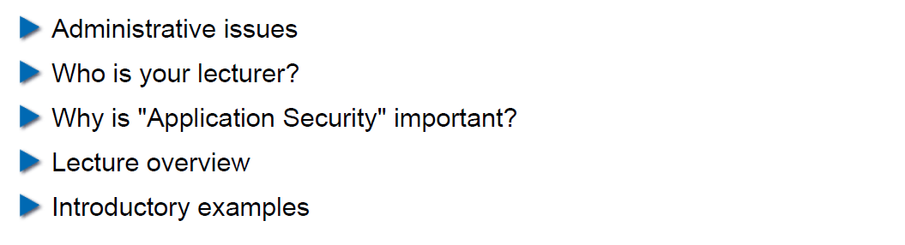

## Administrative Issues

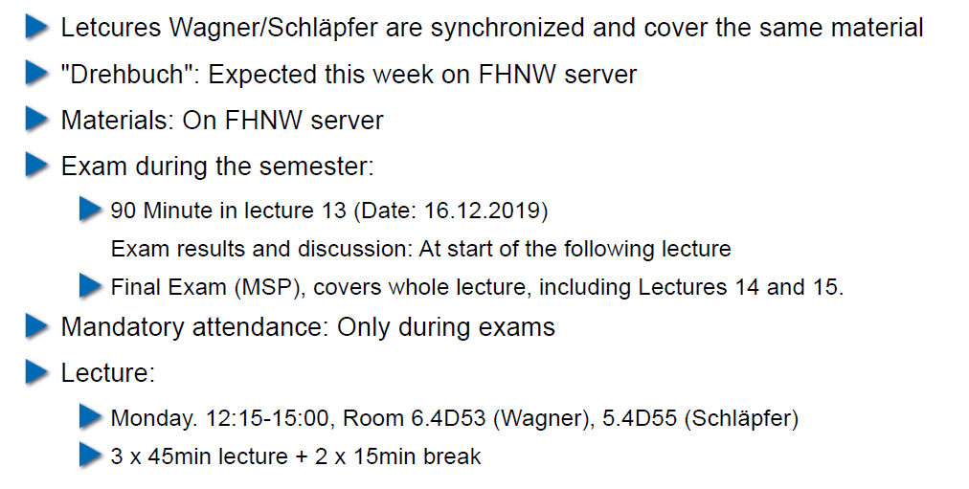

## Who is Your Lecturer (Wagner)

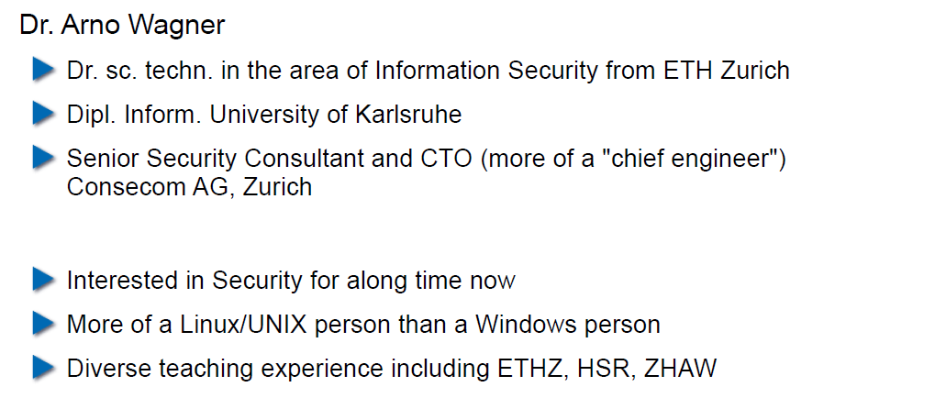

## whoami (Schläpfer)

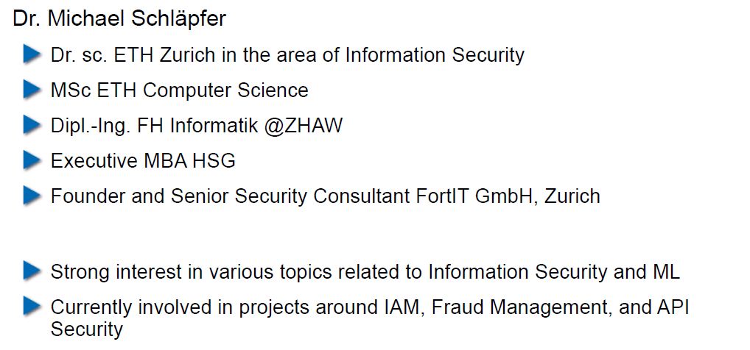

## Why is Application Security Important?

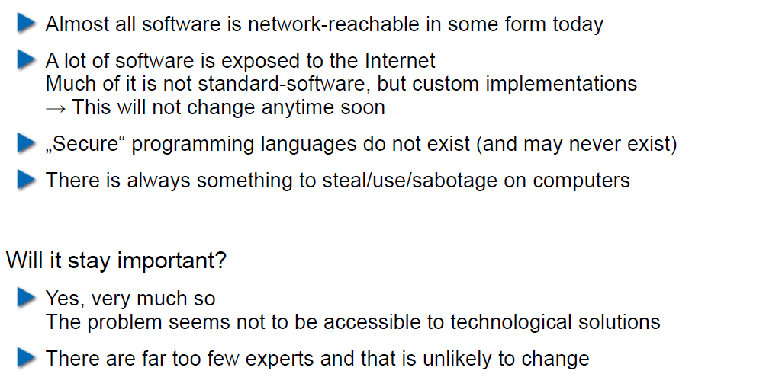

## Lecture Overview (1)

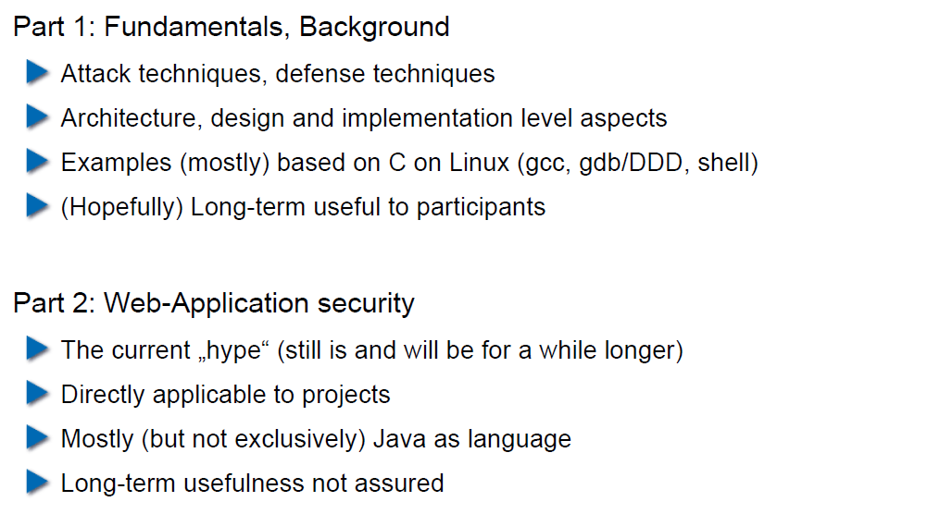

## Lecture Overview (2)

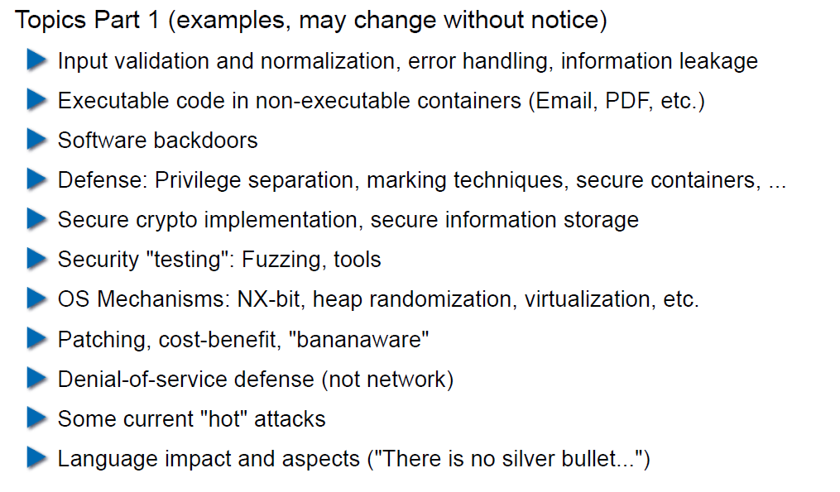

## Lecture Overview (3)

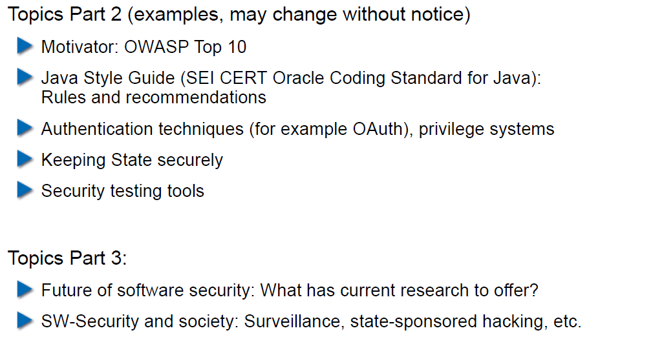

## Example: Buffer Overflow

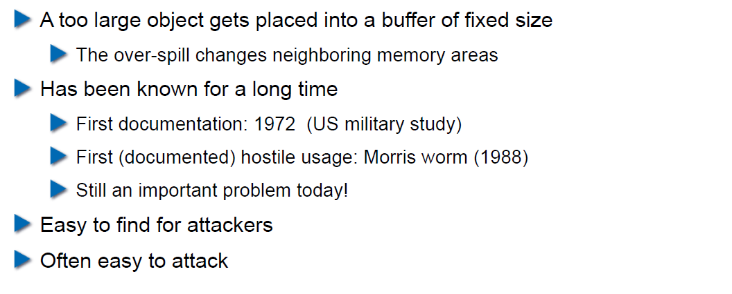

## How does a Buffer Overflow Work?

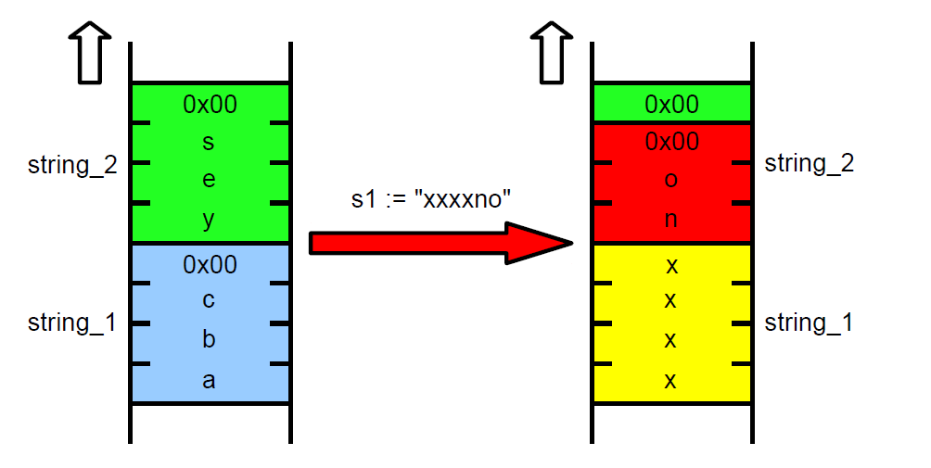

## Buffer Overflow Demo

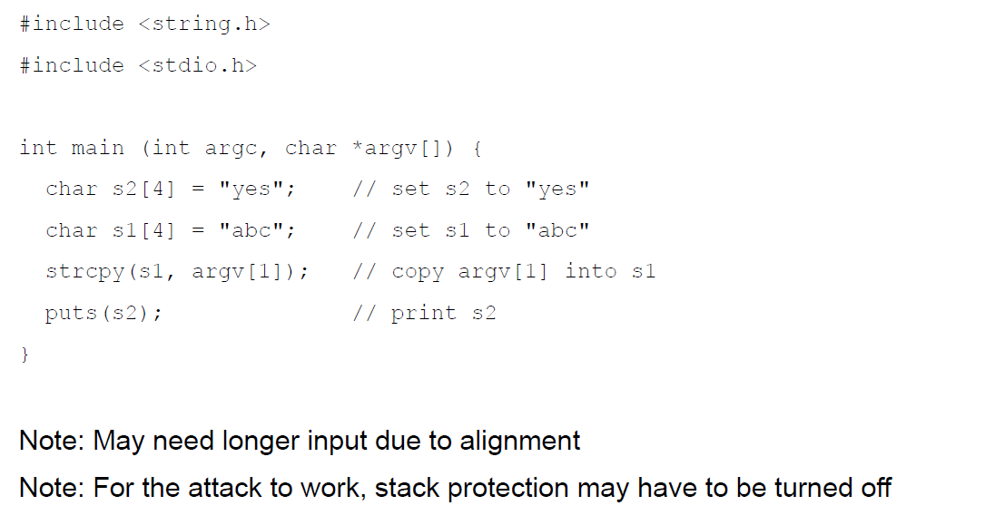

## Not Really a Fix for Buffer Overflow: Stack Protection

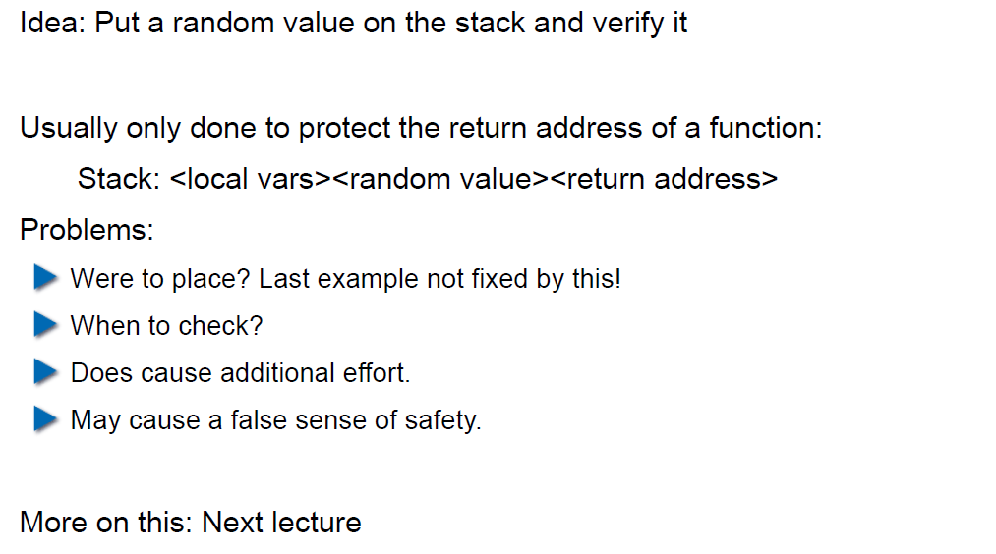

## Fix for Buffer Overflow: Checked Buffers

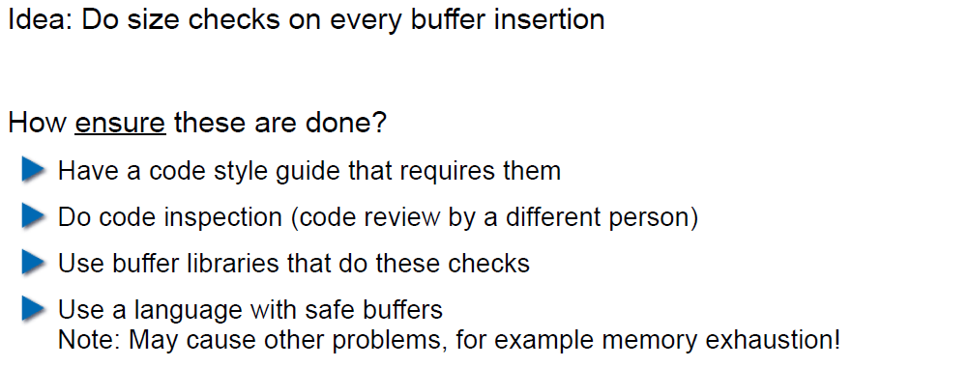

## Example: Taint Checking in Perl (1)

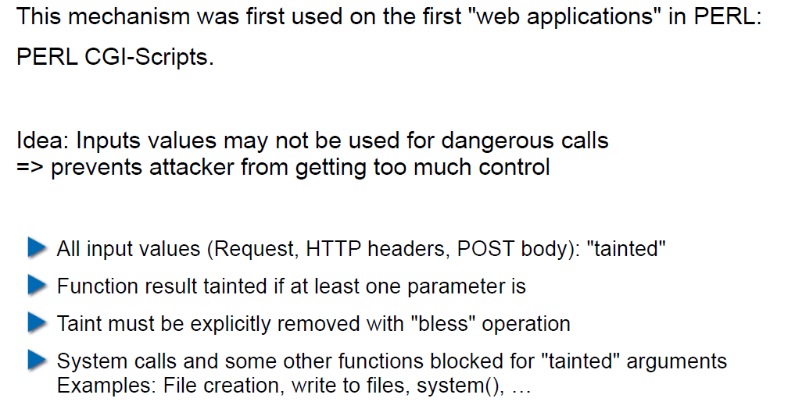

## Example: Taint Checking (2)

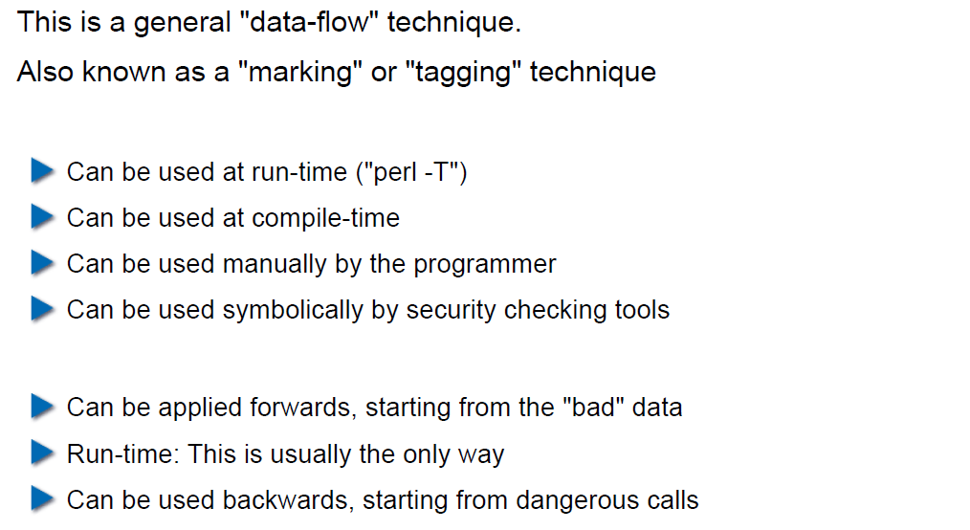

## Example: Taint Checking (3)

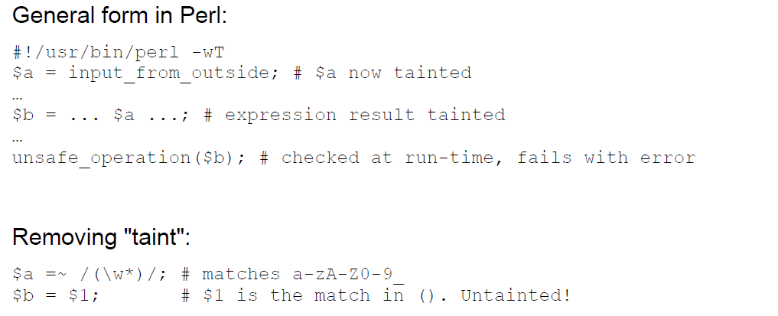

## Example: Taint Checking (4)

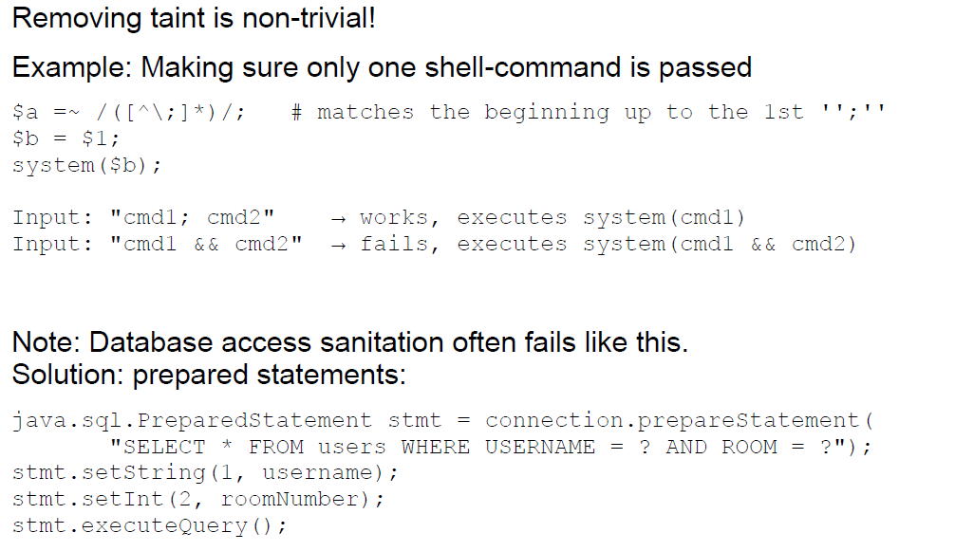

## Example: Data Leakage by Behavior (1)

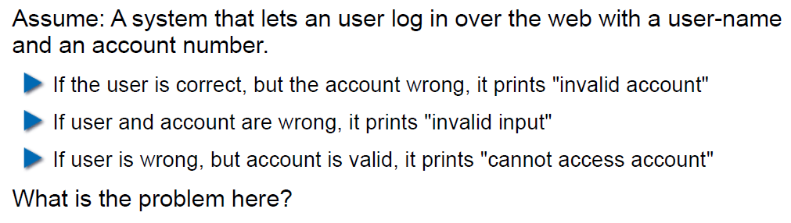

## Example: Data Leakage by Behavior (2)

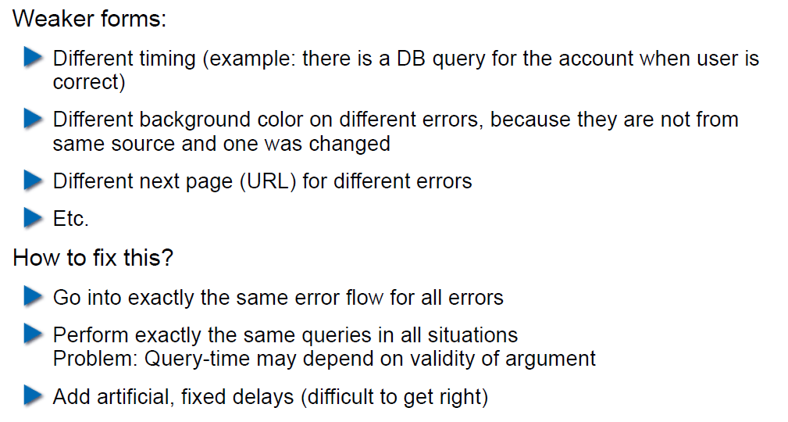

## Example: Data Leakage by Error Output

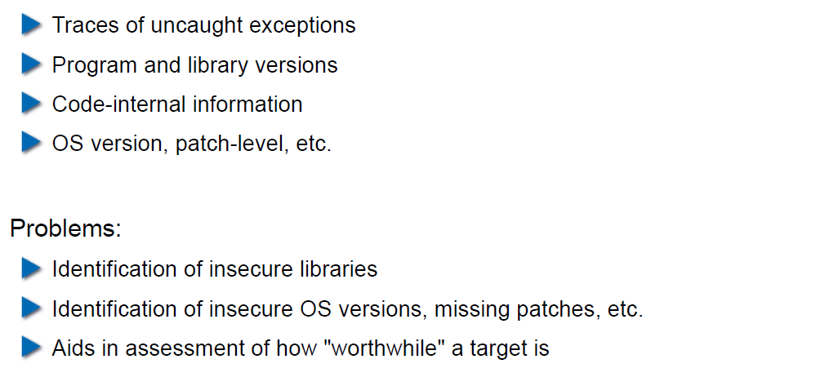

## Human Factors

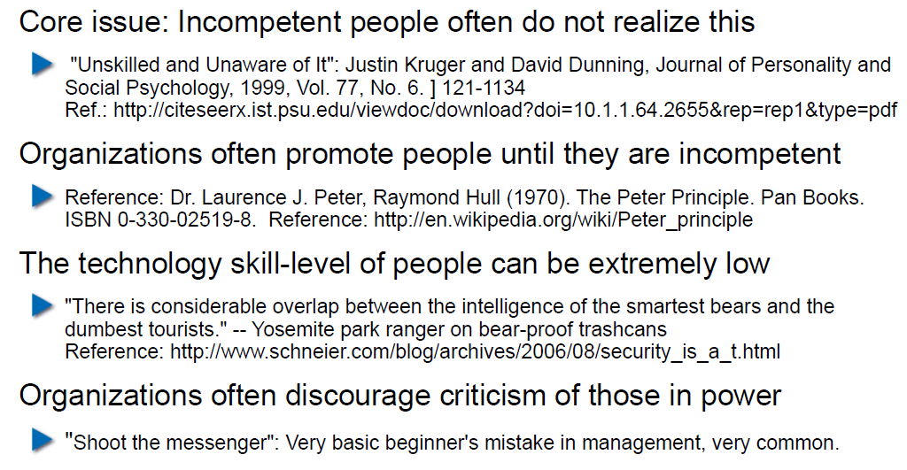

## Exercises and Preparation for Next Week

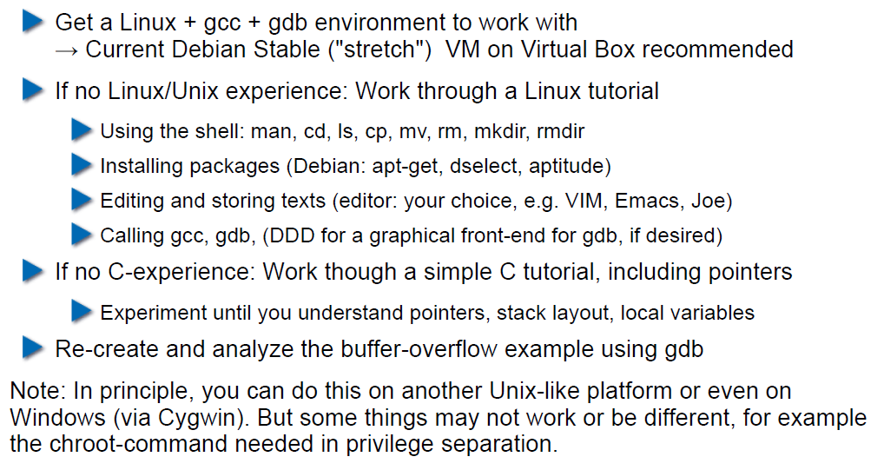

## Reserve

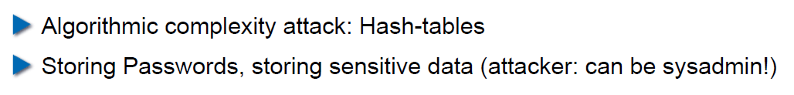

# Woche 2

## Agenda

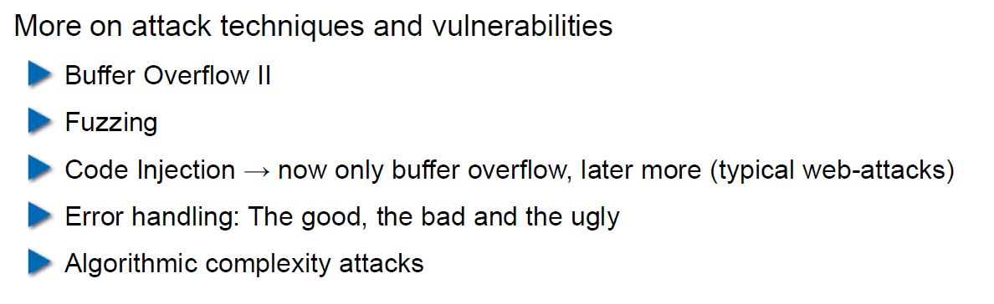

## Recap: What do Attackers Want?

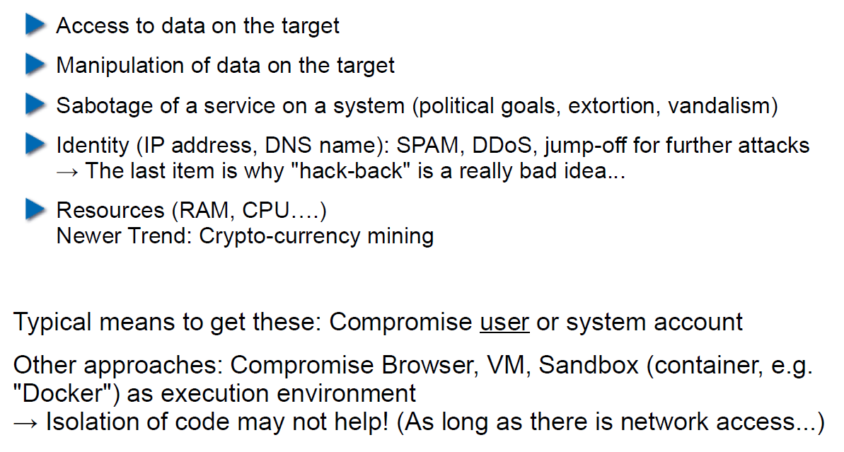

## Buffer Overflow II

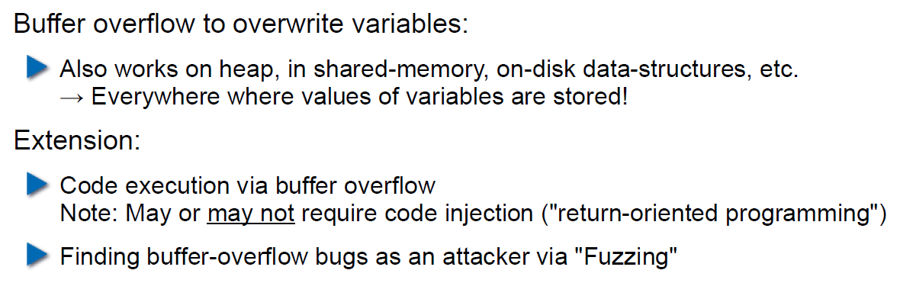

## Buffer Overflow II

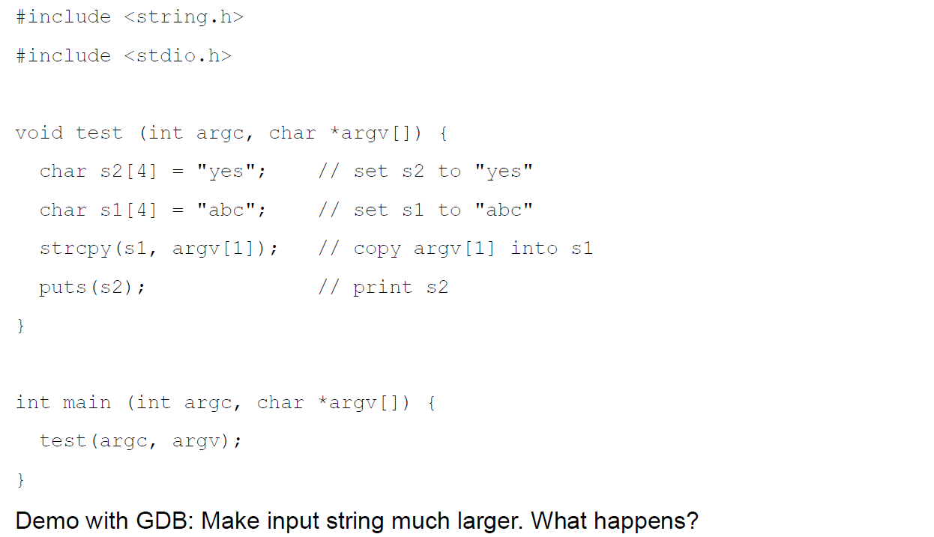

## Buffer Overflow II

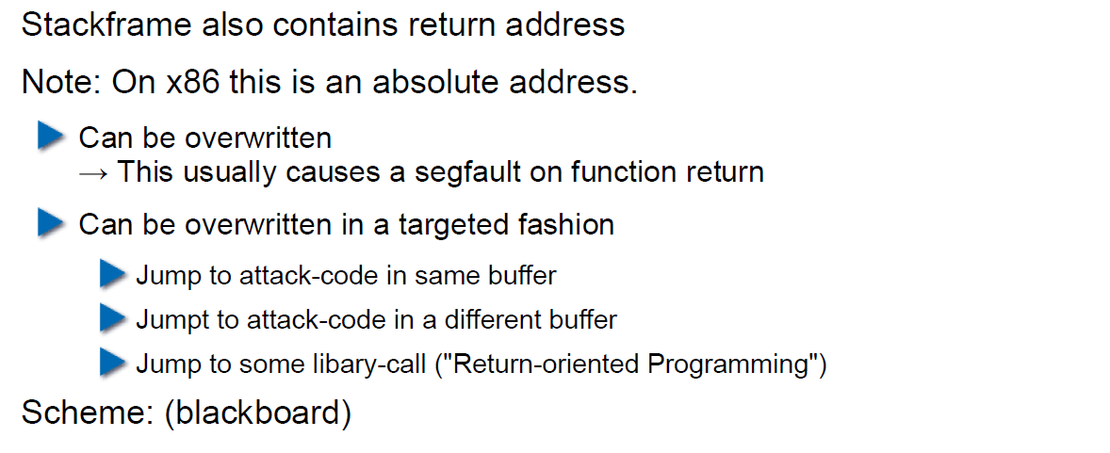

## Buffer Overflow II

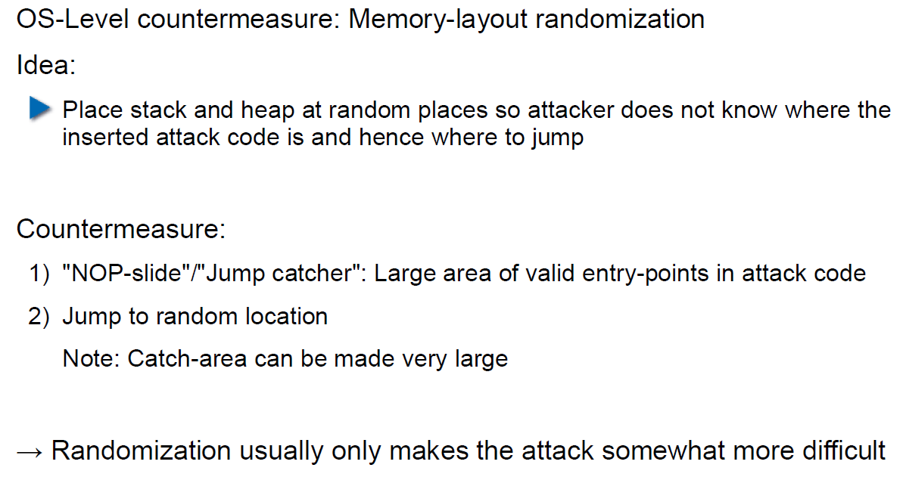

## Buffer Overflow II

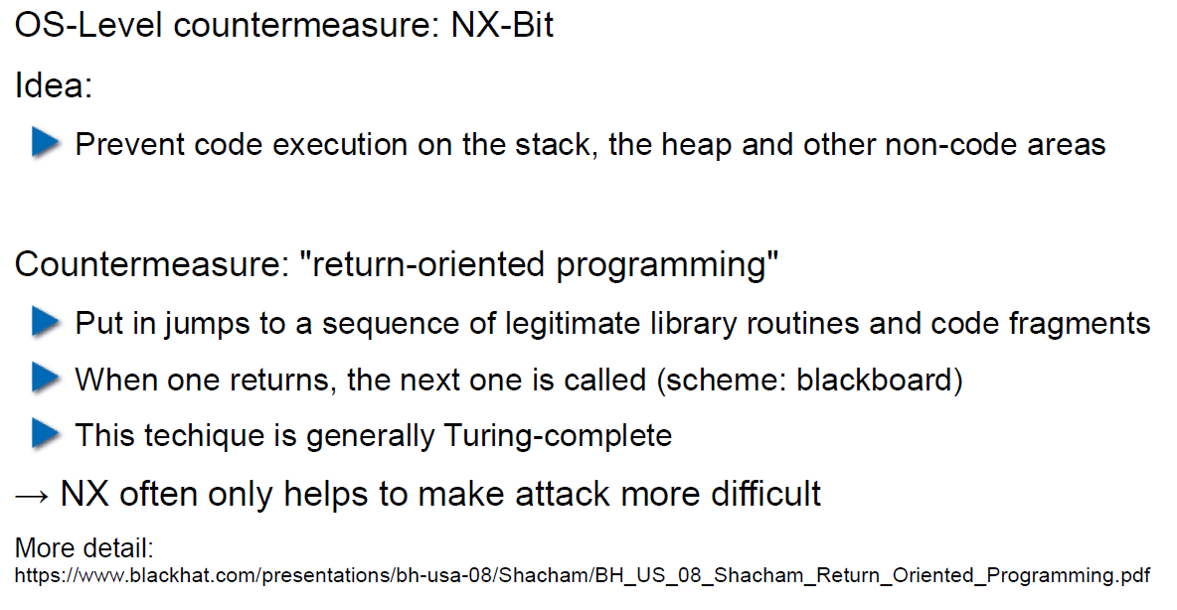

## Attack Technique: Fuzzing

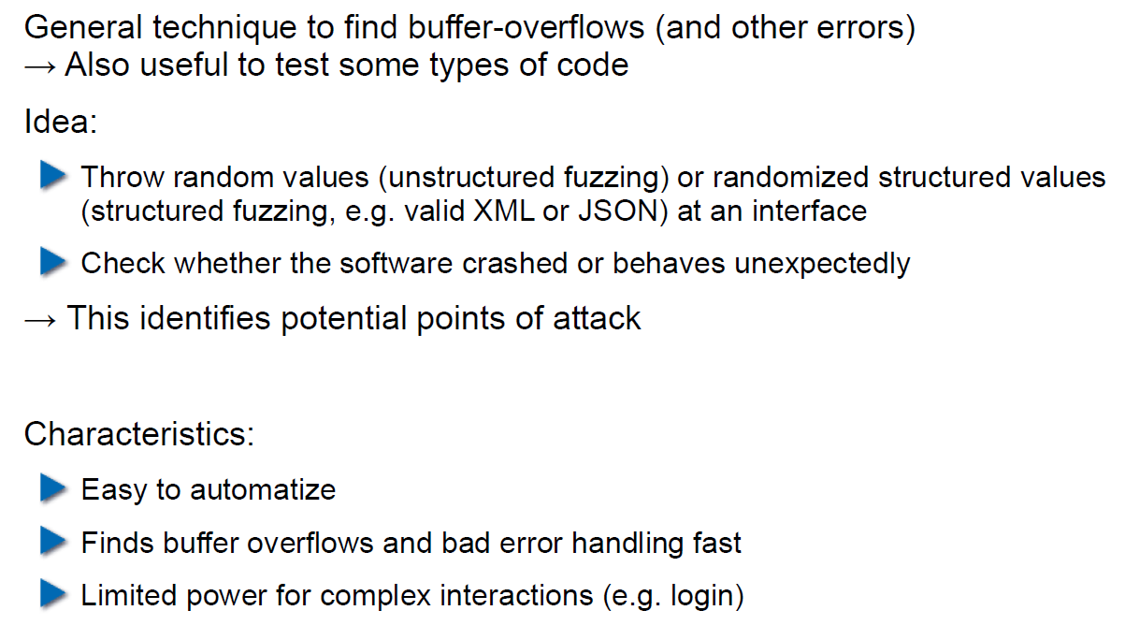

## Error Handling

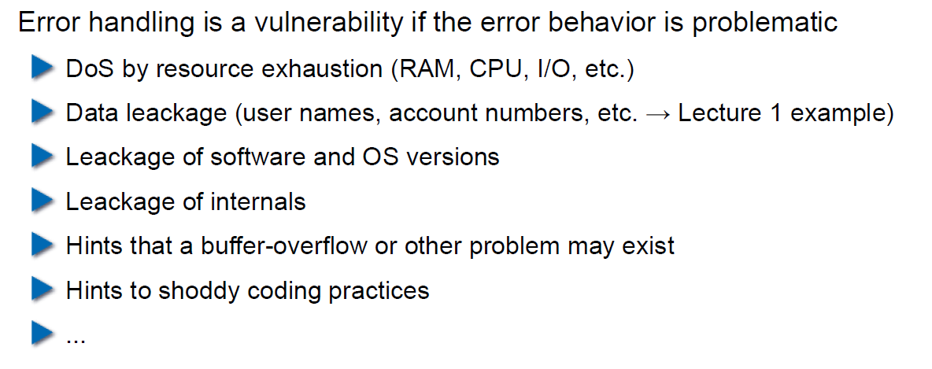

## Case study – Handling too long input

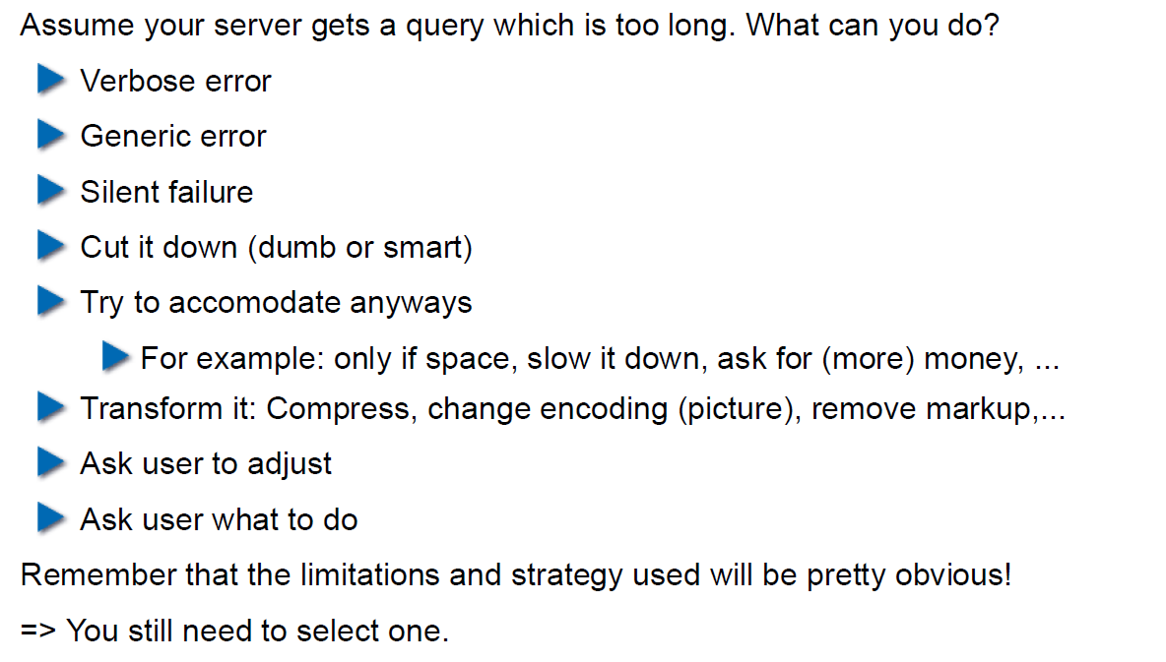

## Case-study: Compression Bomb

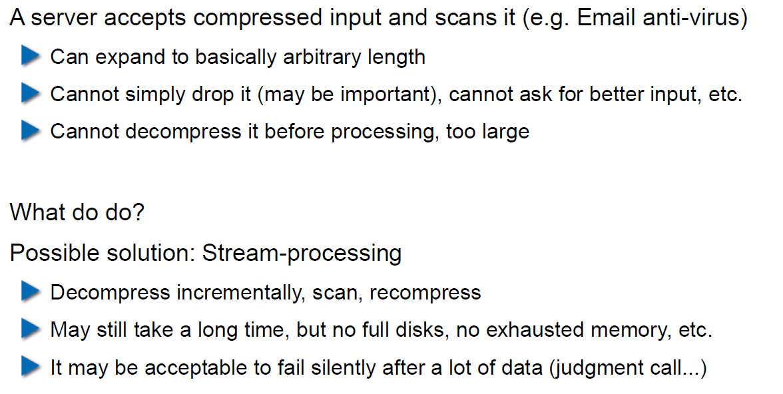

## Error Handling

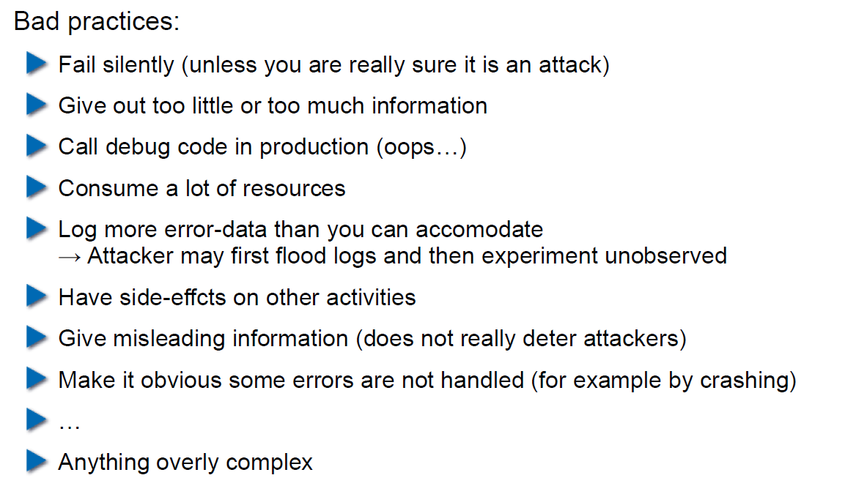

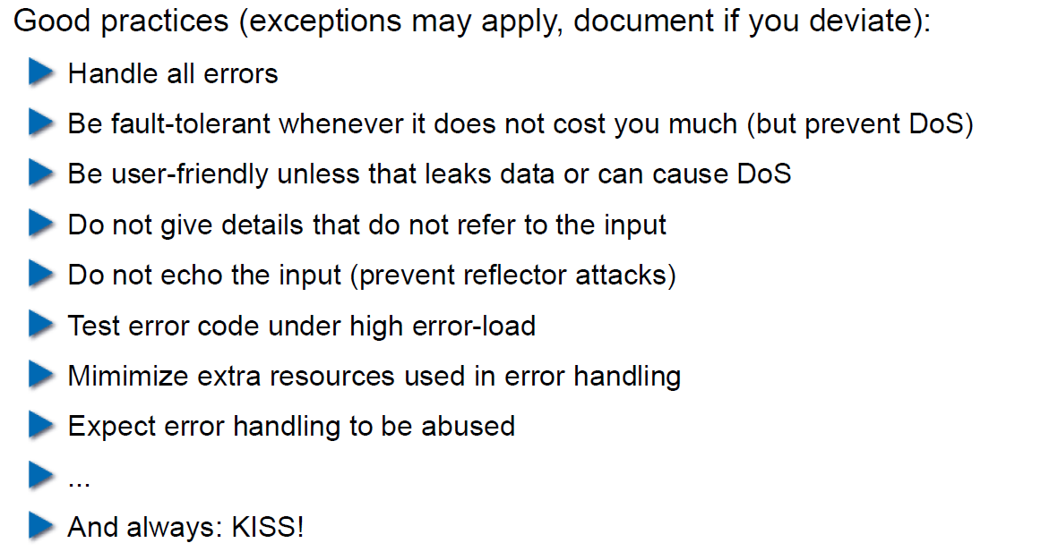

## Algorithmic Complexity Attacks

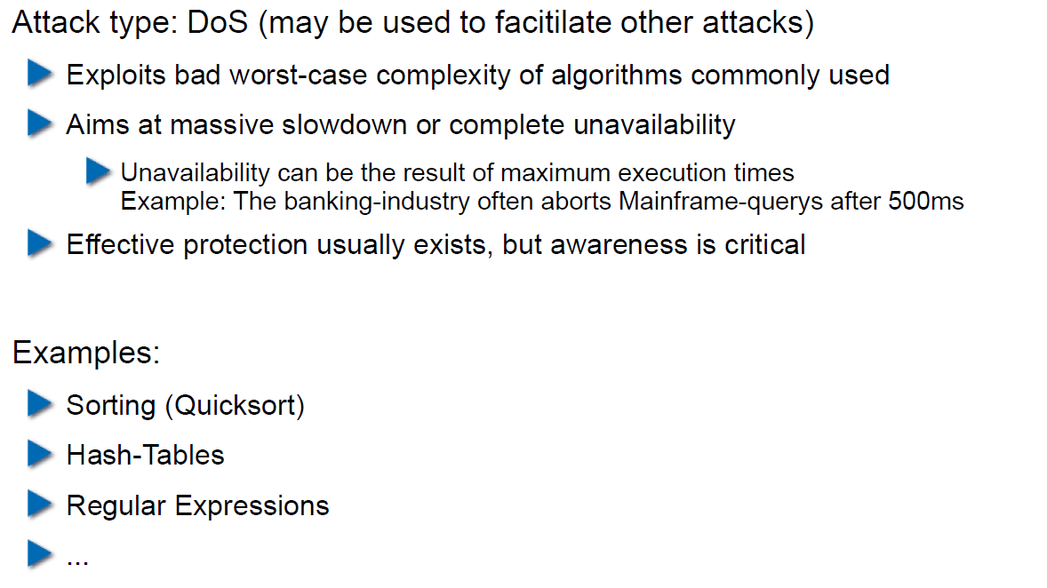

## Algorithmic Complexity: Sorting

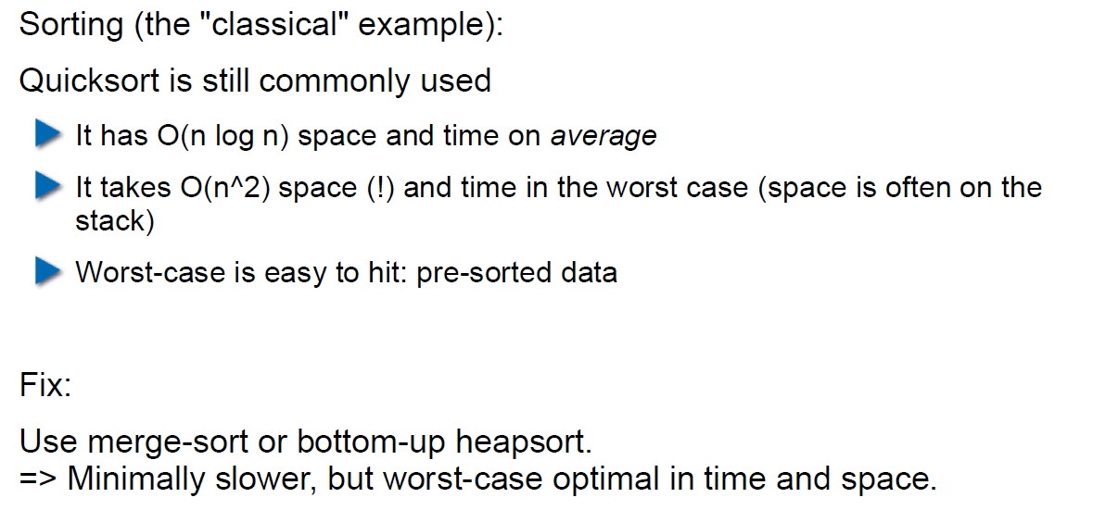

## Algorithmic Complexity: Hashing

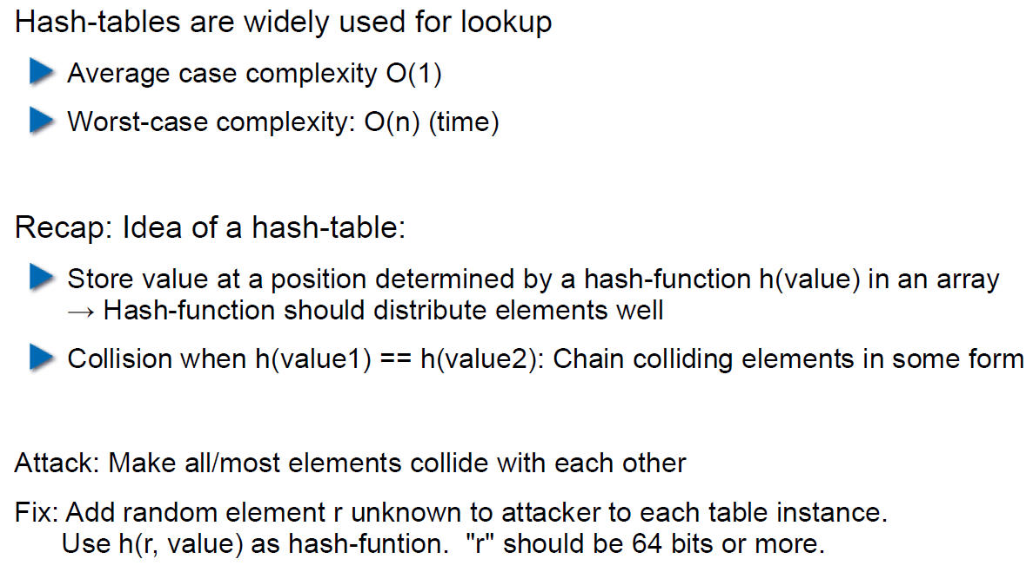

## Algorithmic Complexity: Regular Expressions

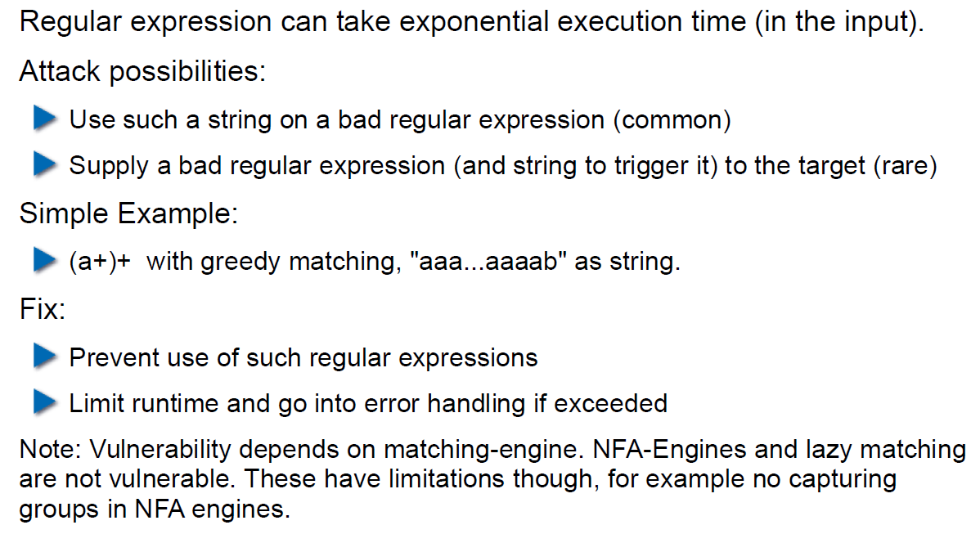

# Woche 3

## Agenda

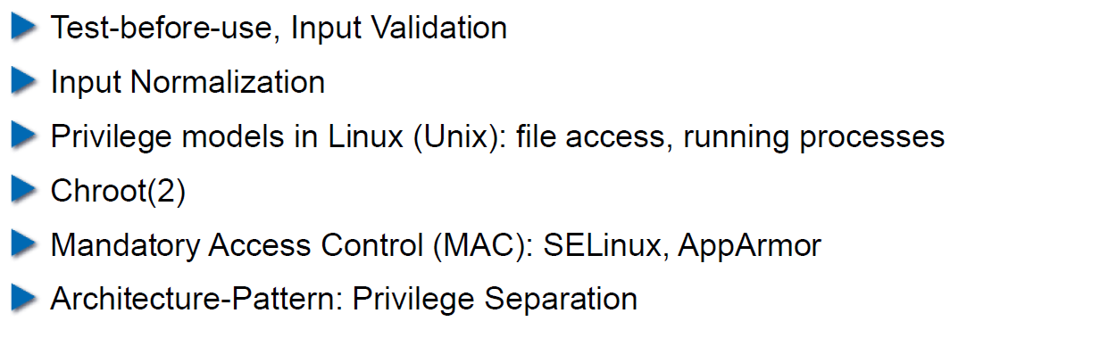

## Secure Coding Principle: Test-before-use

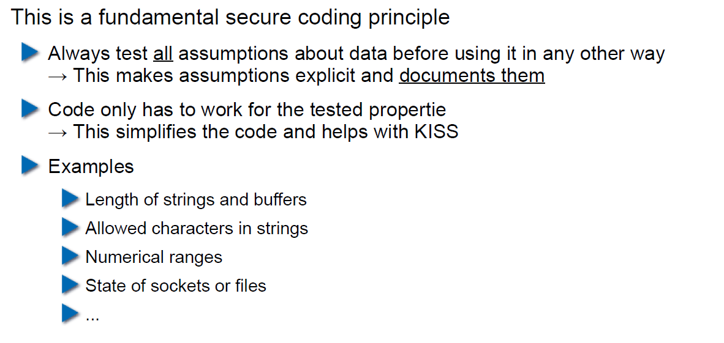

## Input Validation

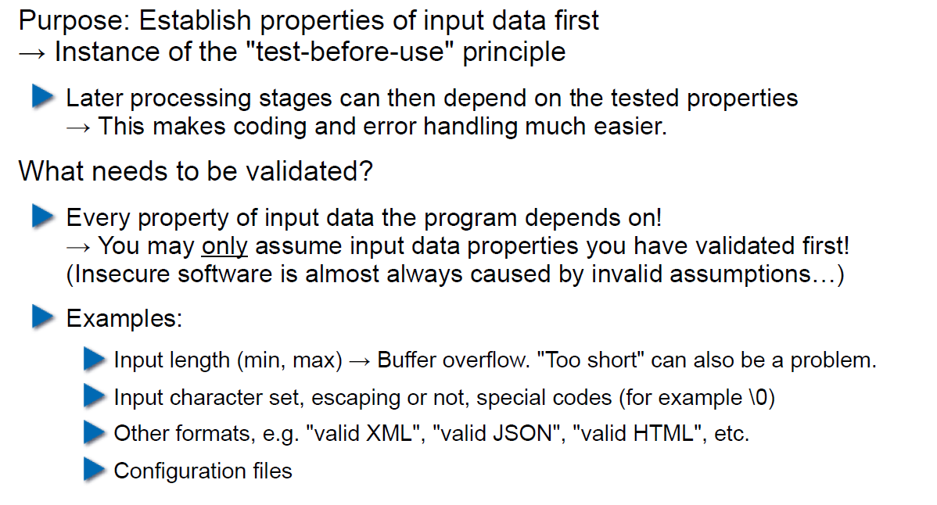

## Input Normalization

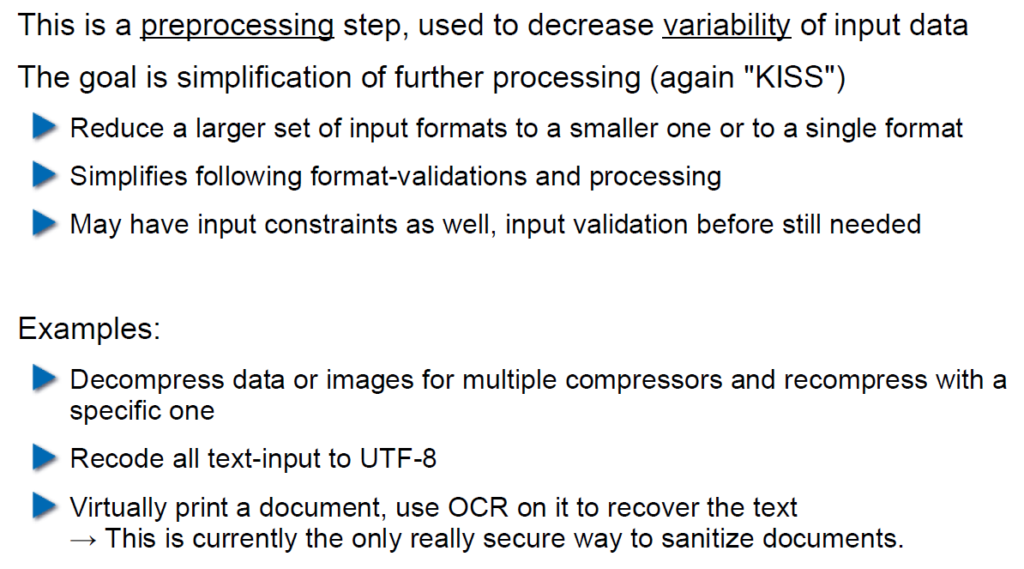

## Unix Permission Model (simplified)

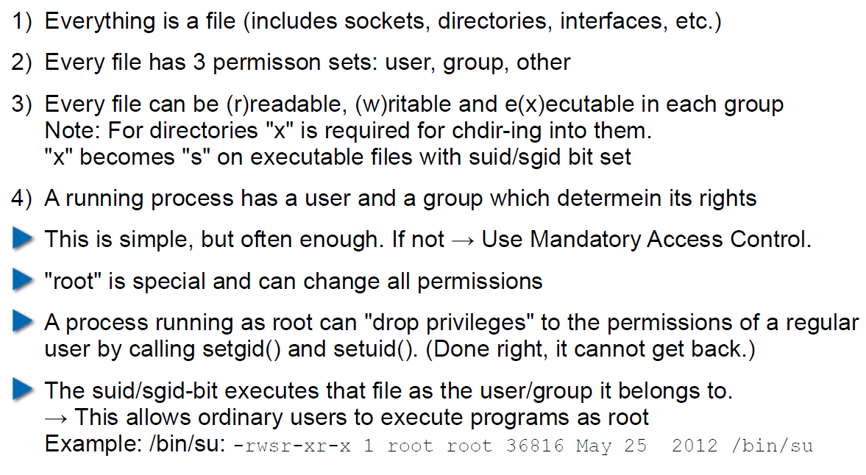

## Chroot

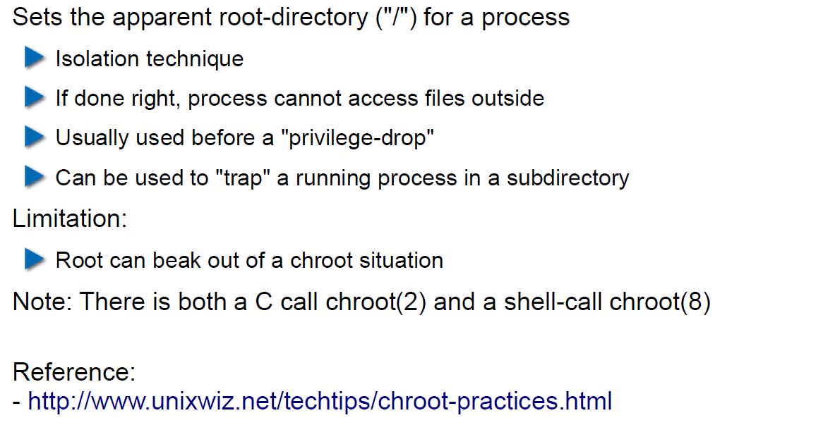

## Mandatory Access Control (MAC)

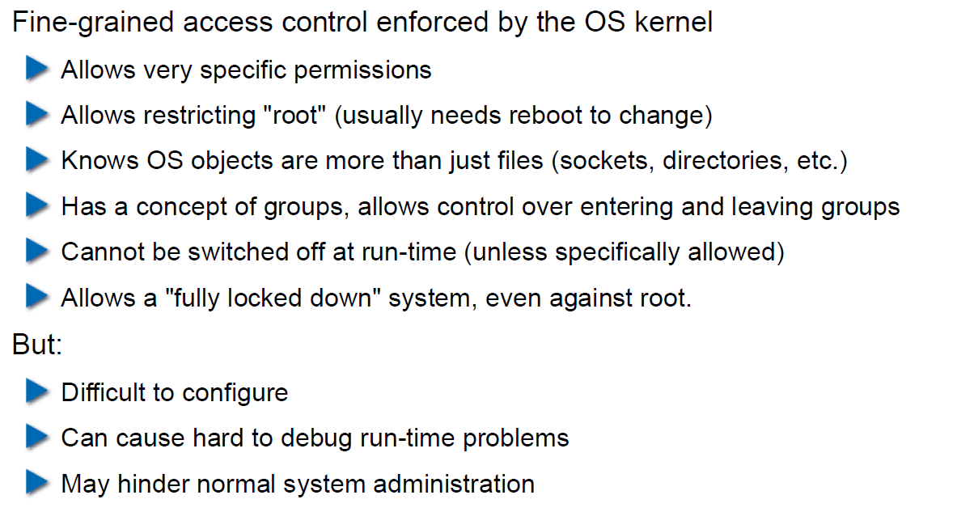

## MAC Example: SELinux

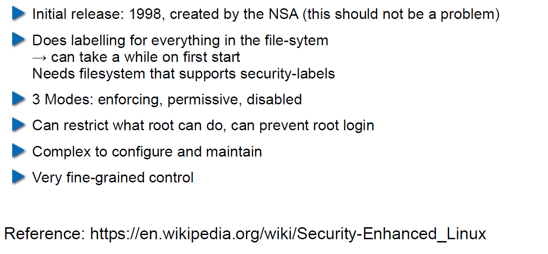

## MAC Example: AppArmor

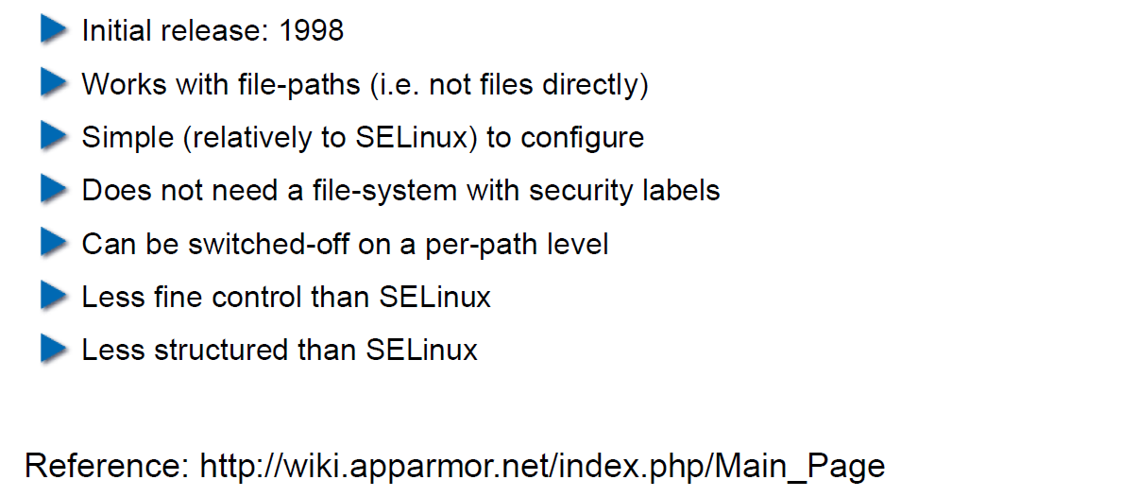

## Secure Coding Principle: Defense in Depth

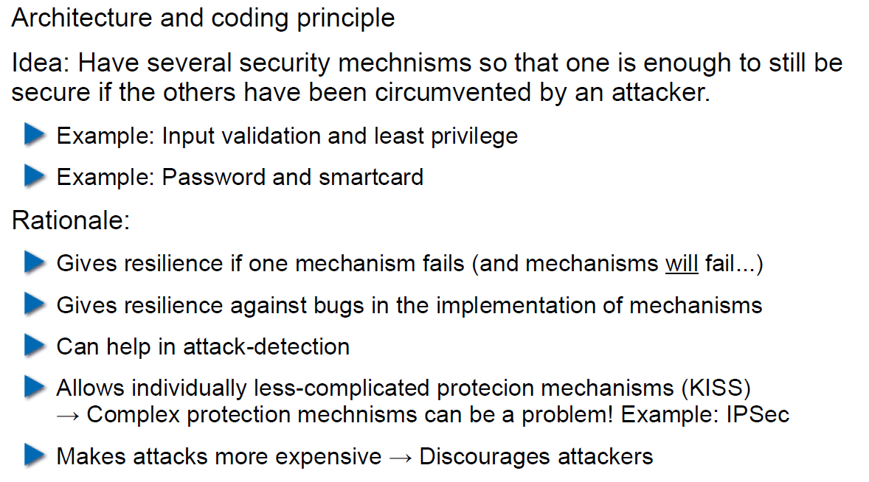

## Privilege Separation

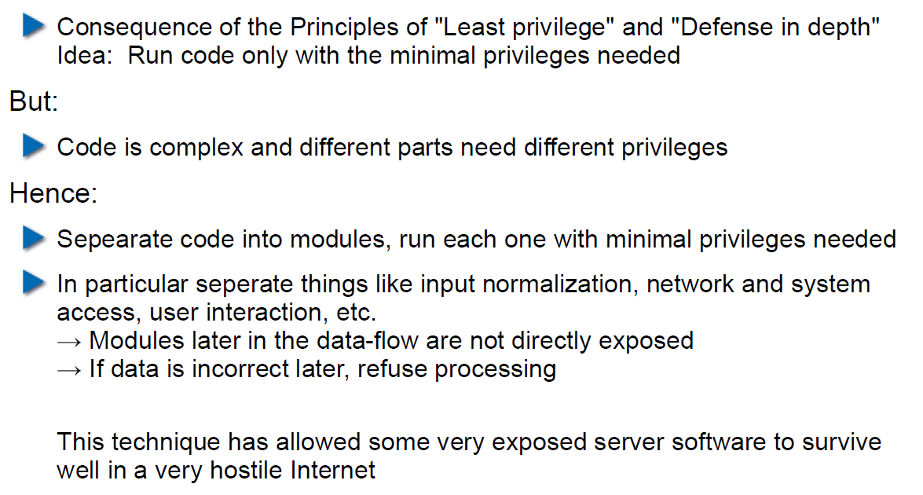

## Overall Idea

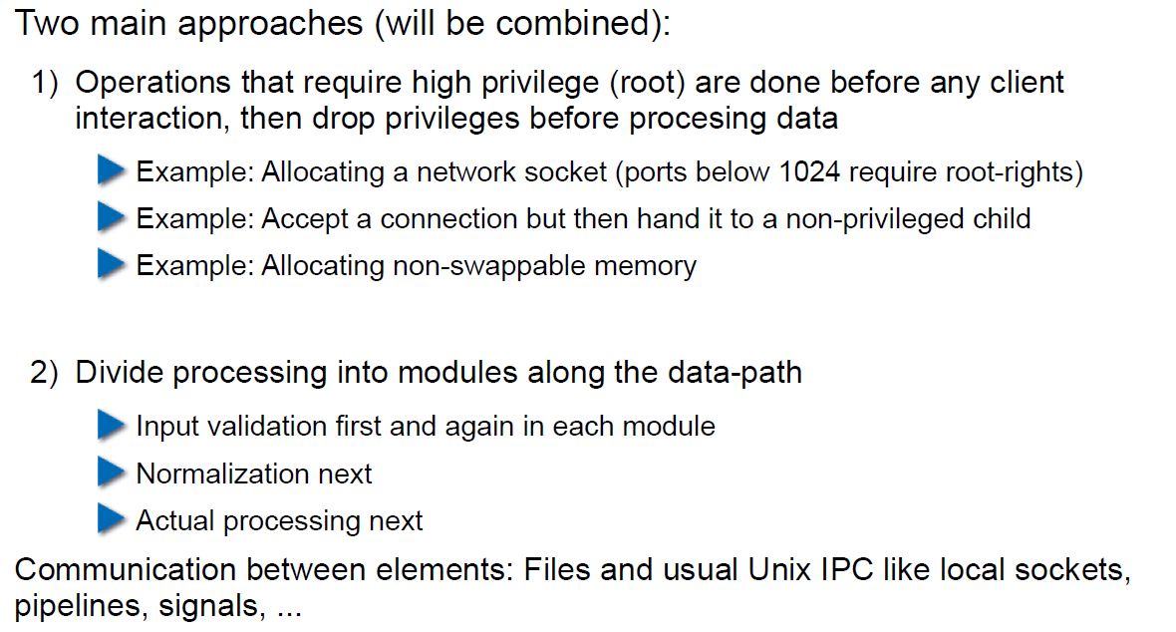

## Form of the Modules

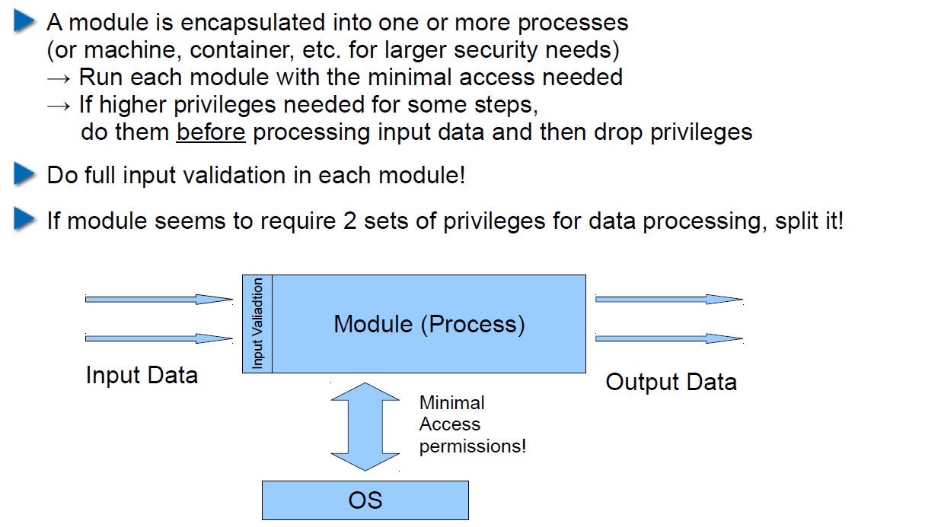

## Example: OpenSSH

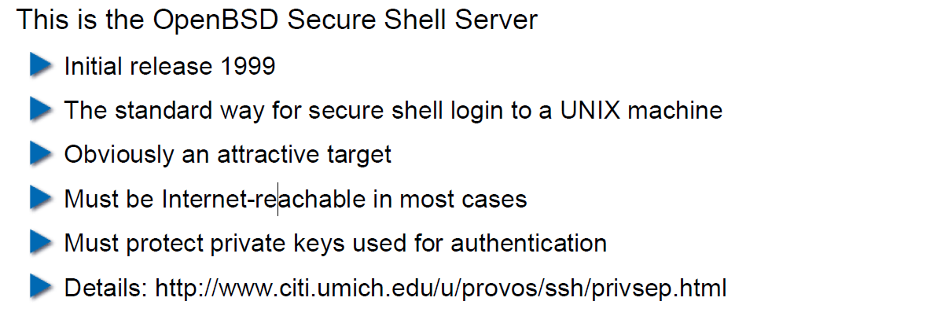

## OpenSSH: Privilege Separation Approach

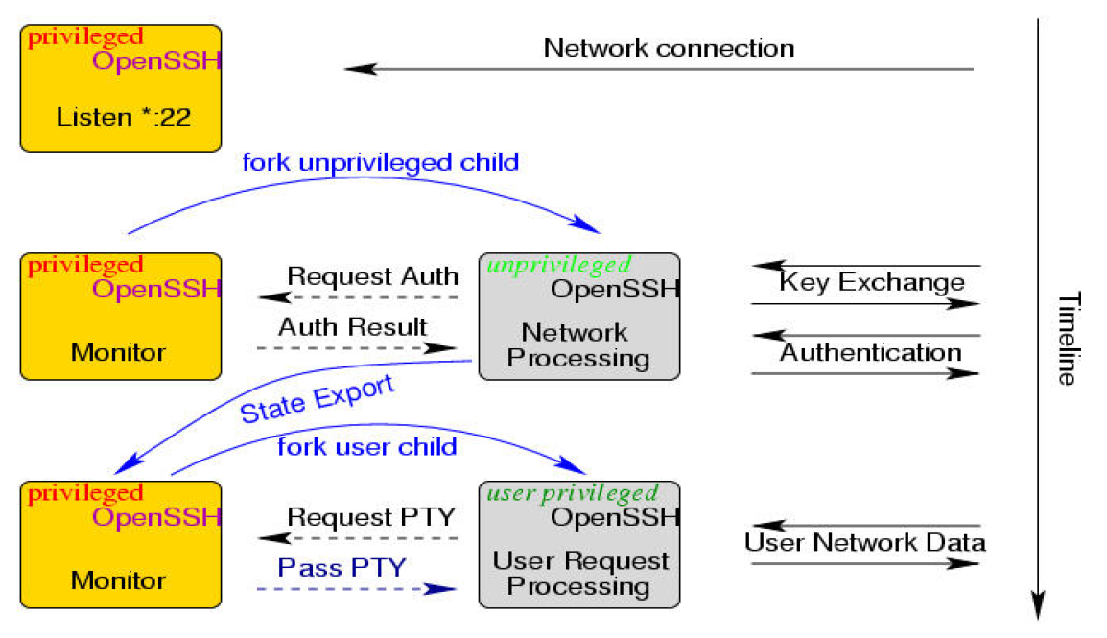

## Example: Postfix MTA (Email Server)

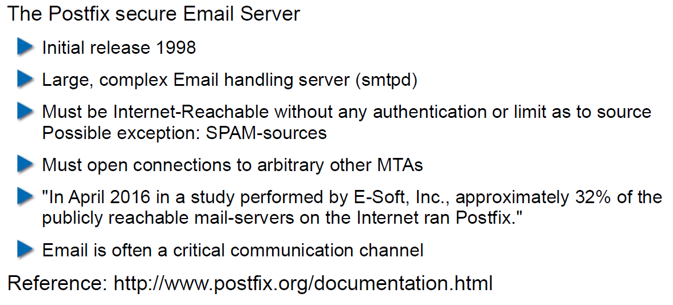

## Postfix System View

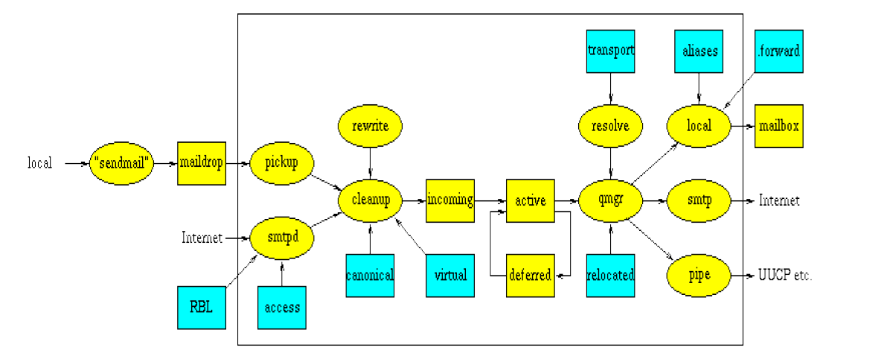

## Postfix: Example Data-Flow

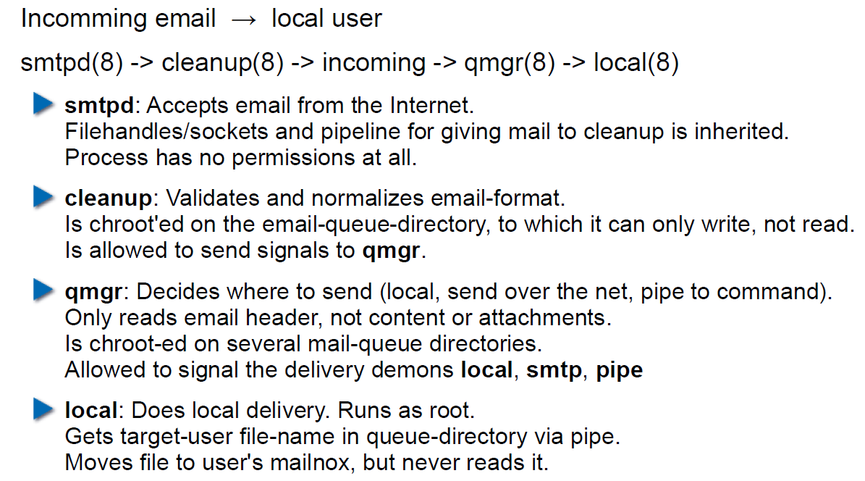

# Woche 4

## Agenda

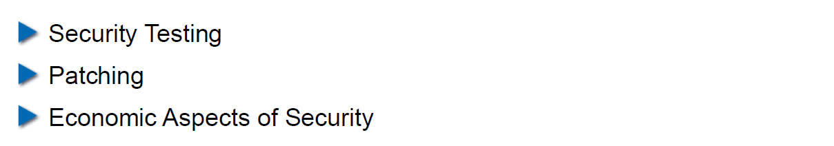

## Security Testing (for Software)

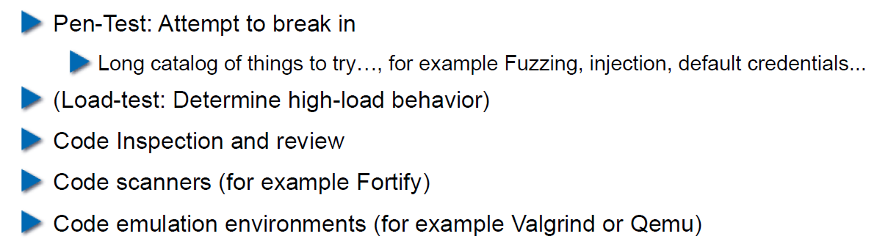

## Pen-Test

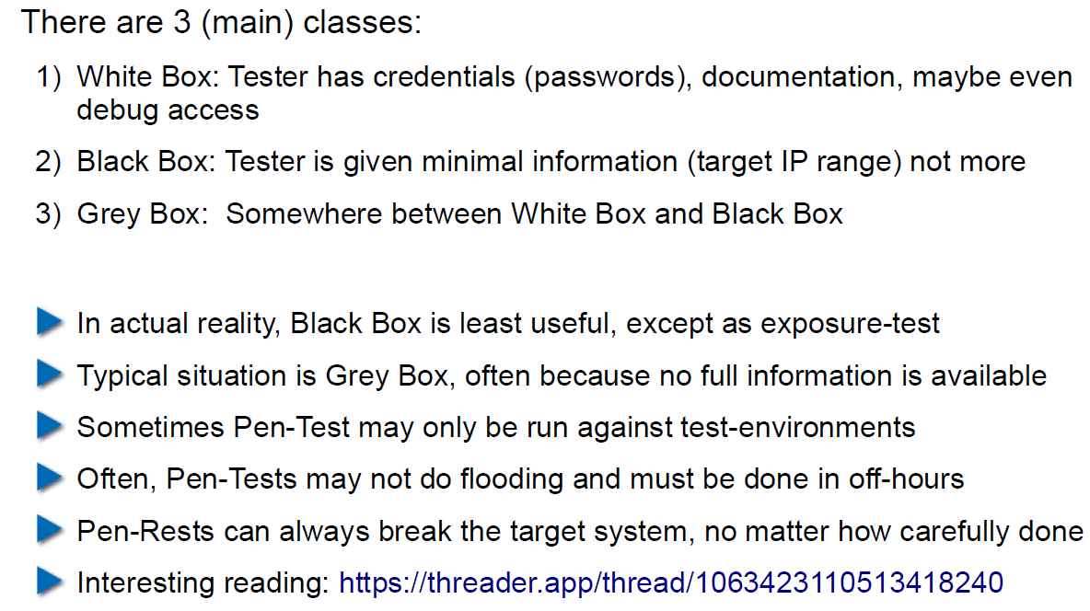

## How does a Pen-Test fail?

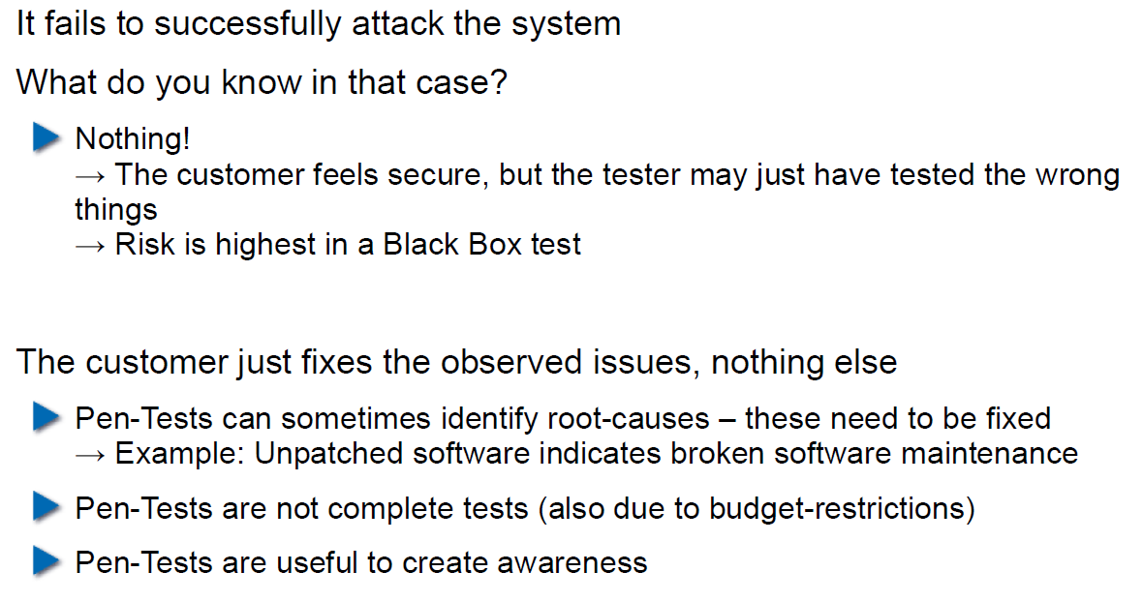

## Code Inspection and Review

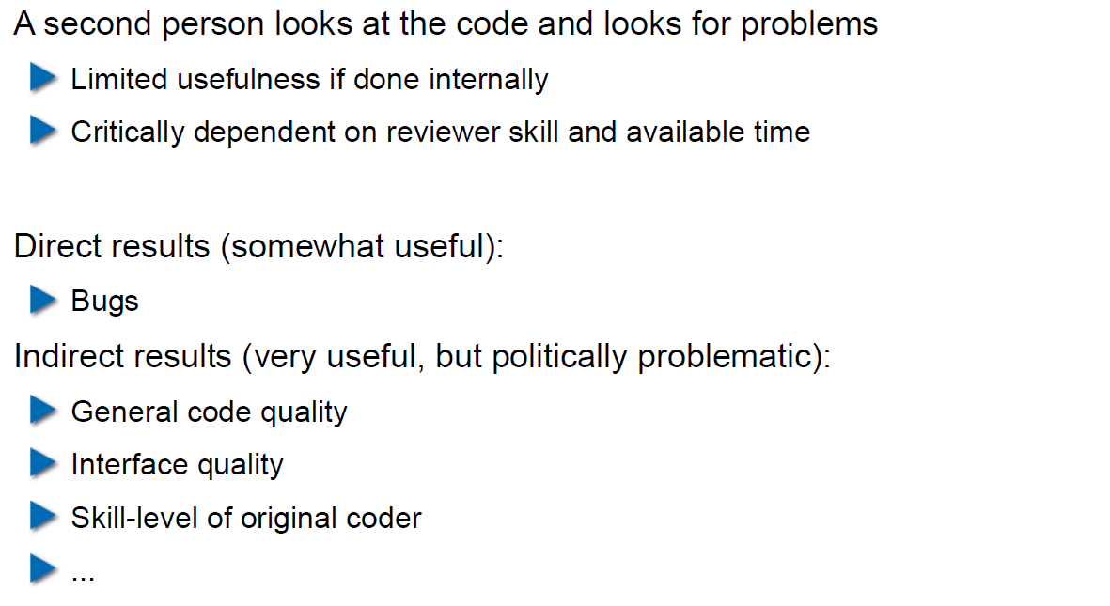

## Code Scanners

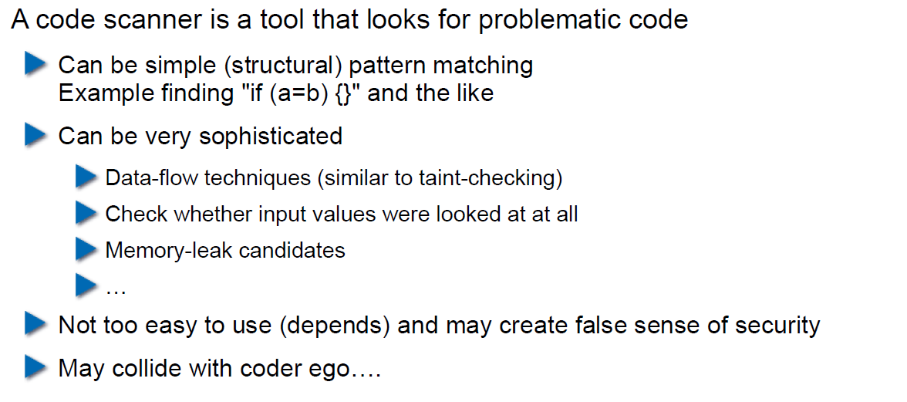

## Execution Emulators

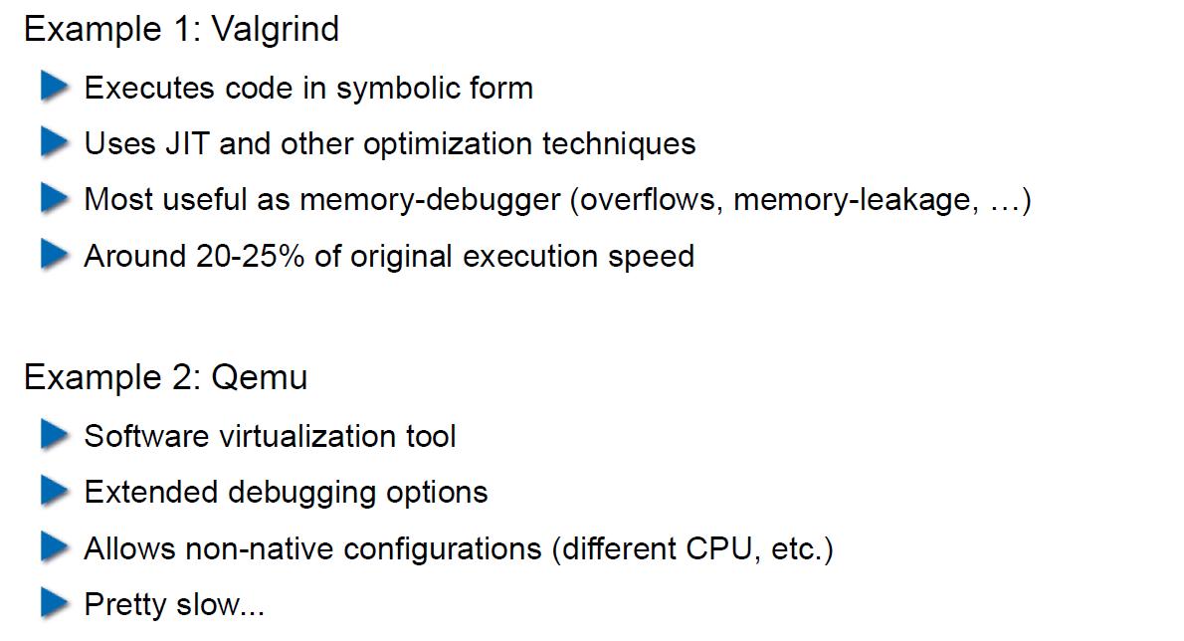

## Patching

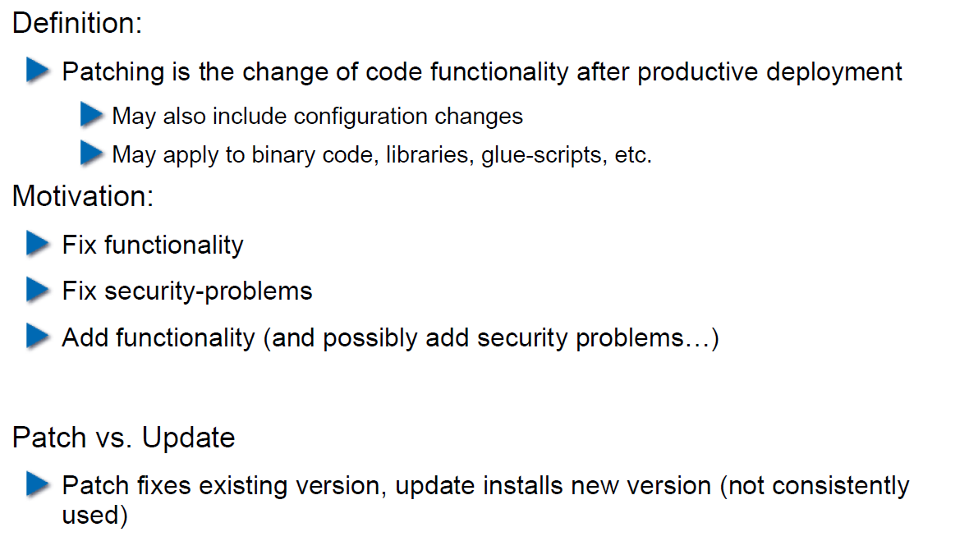

## How to Patch

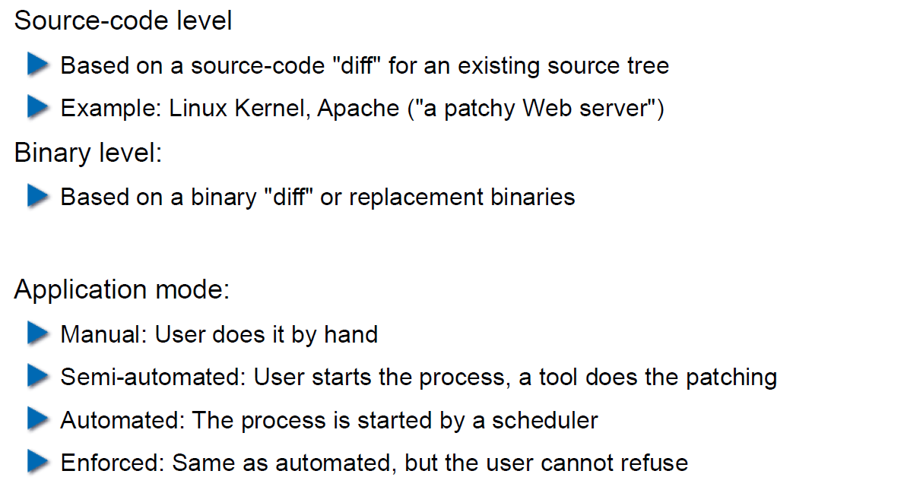

## Problems with Patching

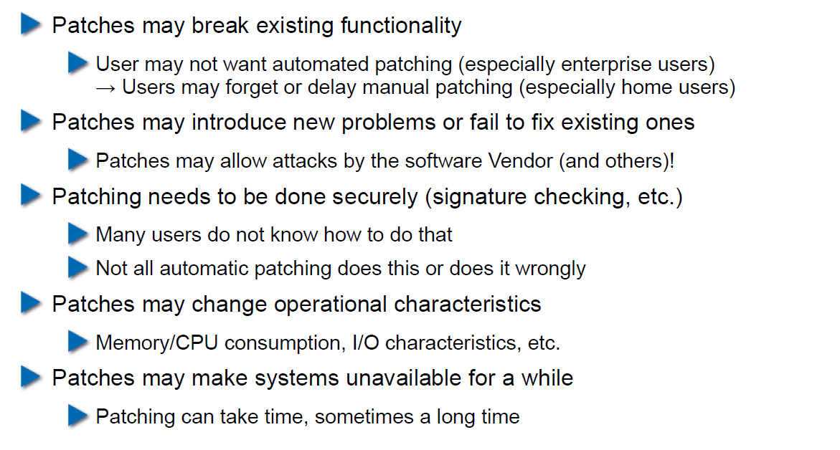

## Problems with not Patching

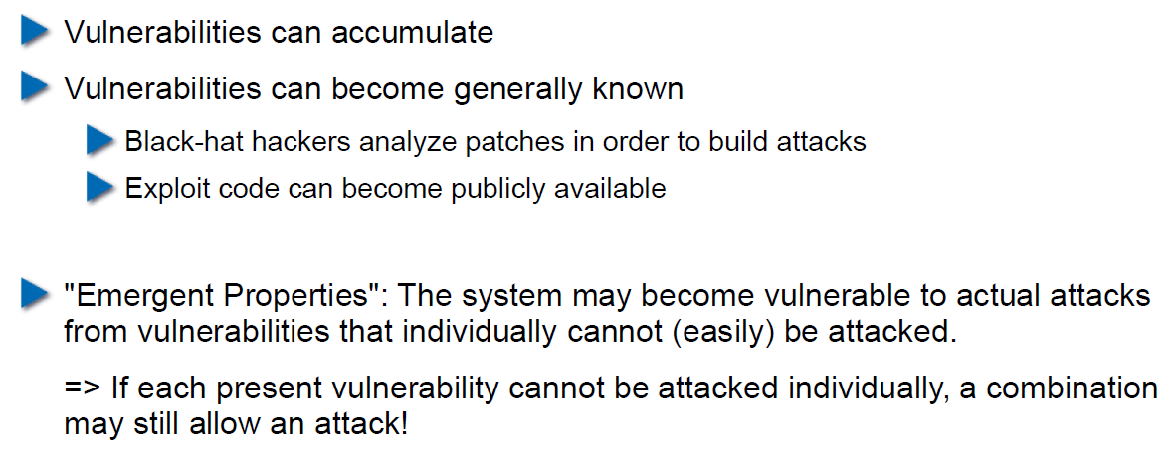

## Problems with Unavailability of Patches

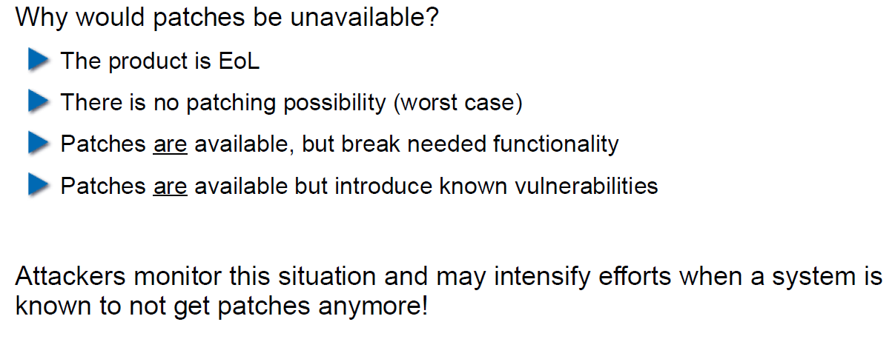

## Economic Aspects of Security

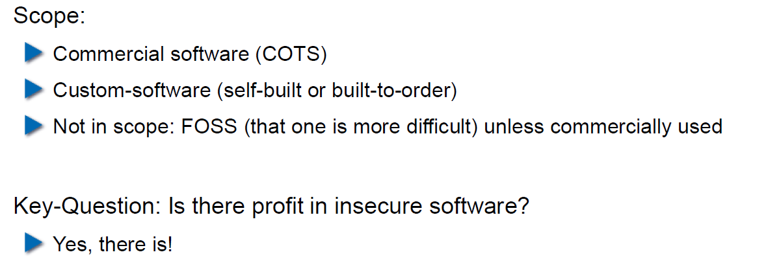

## Case Study: DDoS on Brian Krebs (20.9.2016)

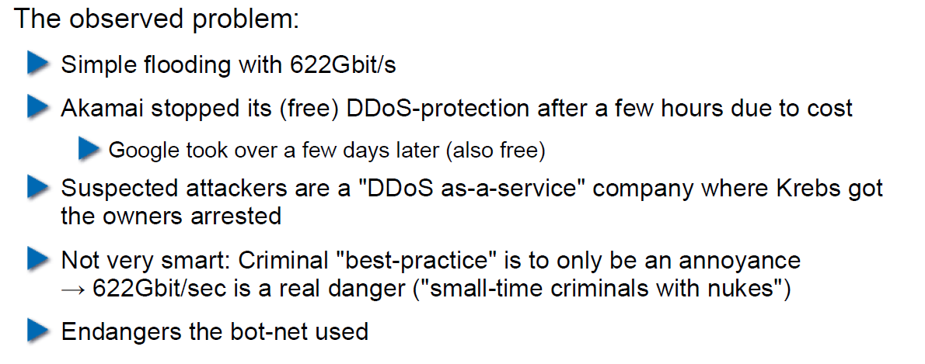

## What can Perform Such an Attack?

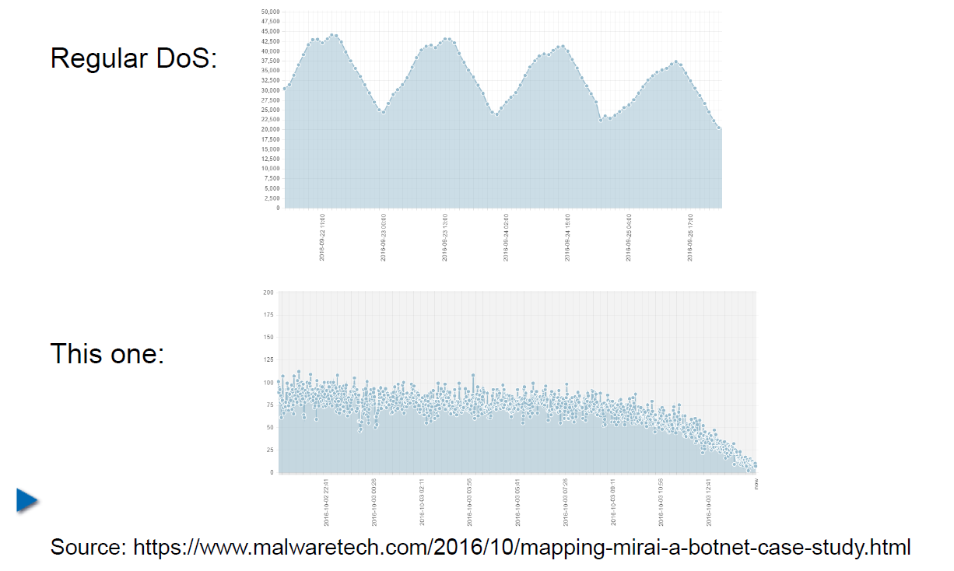

## IoT: Internet of insecure Things

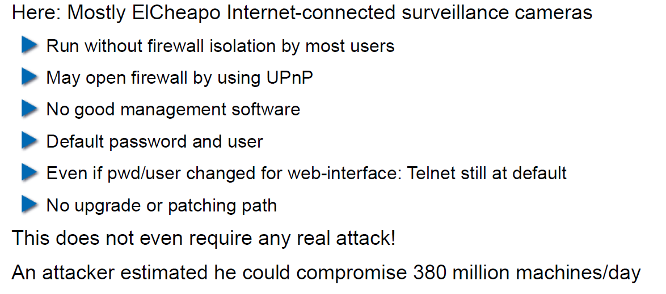

## Why are These IoT Devices so Insecure?

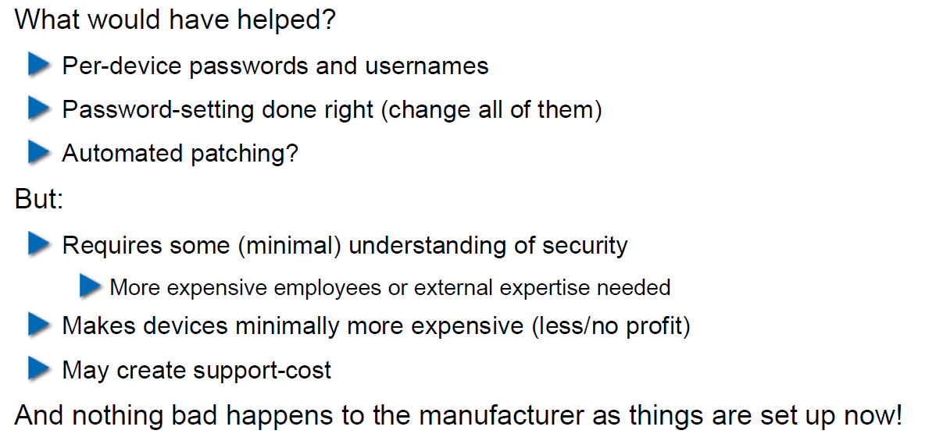

## Possible Solutions

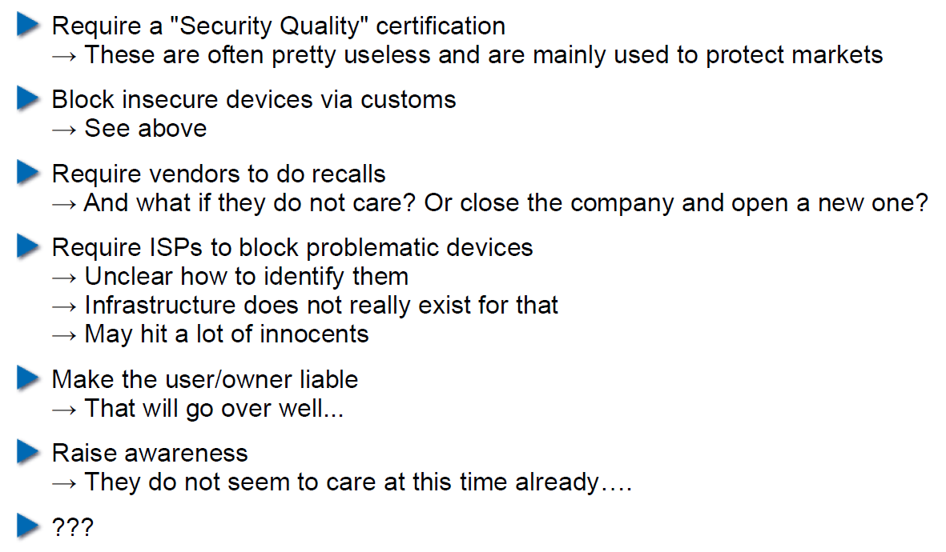

## Does it Pay to make Software Secure?

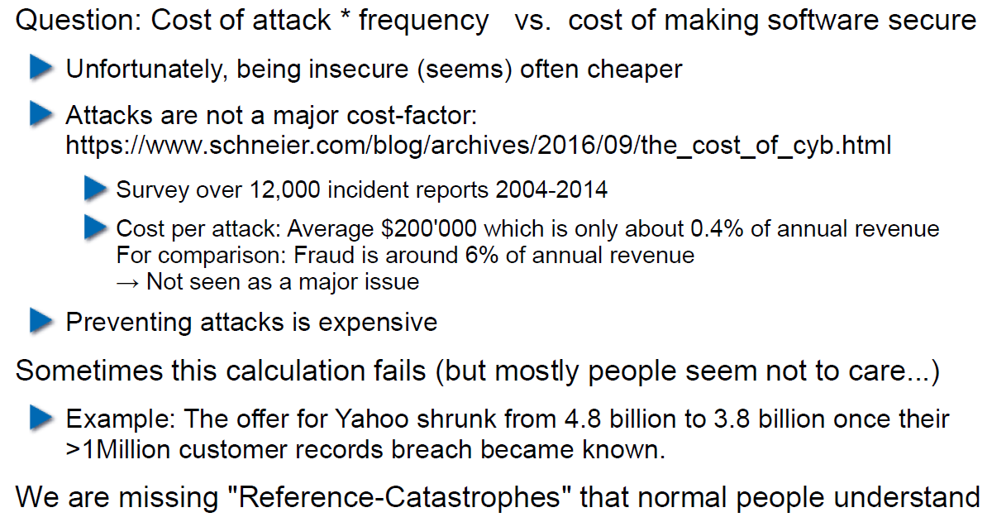

## So, what to do?

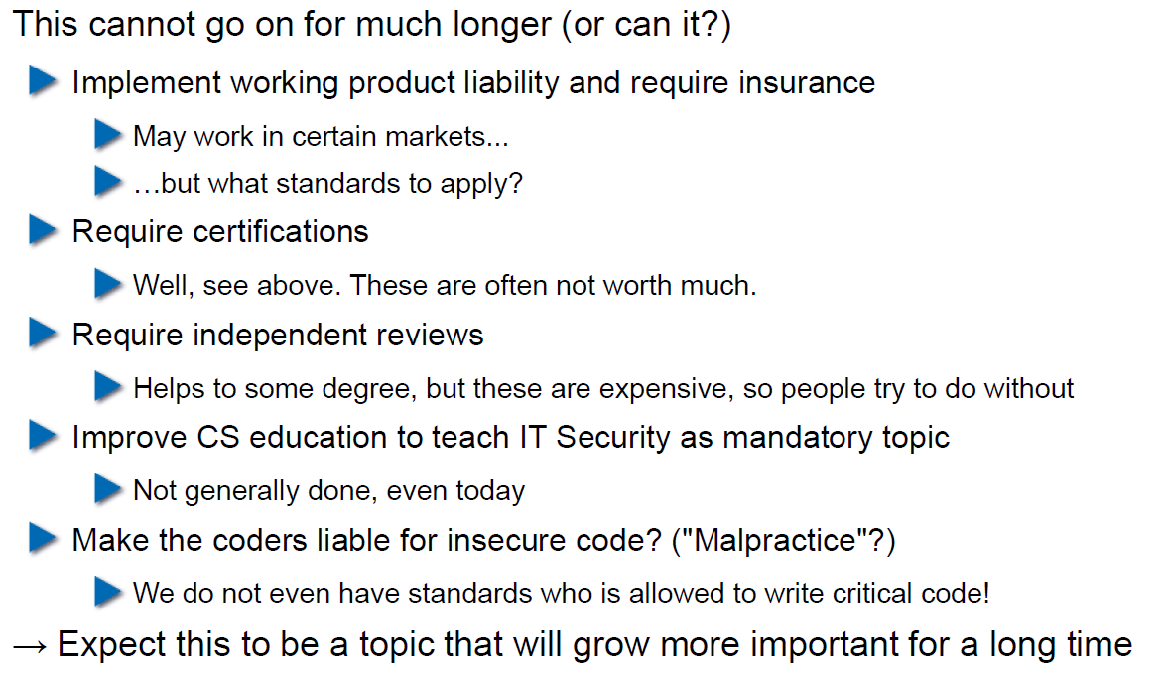

# Woche 5

## Agenda

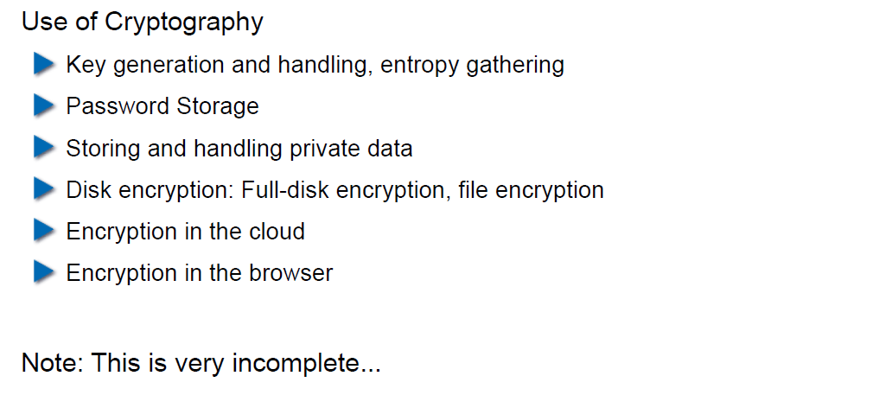

## Generating Cryptographic Keys

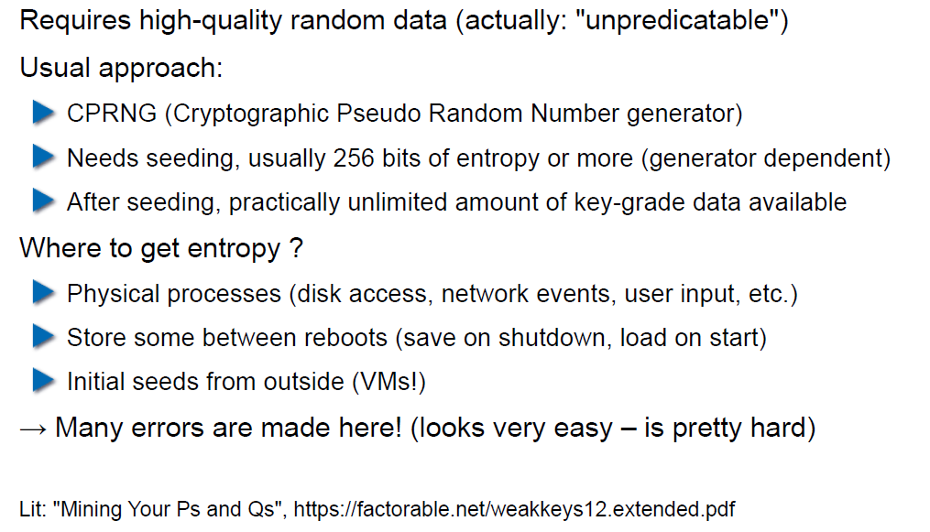

## Information-Theoretical Entropy

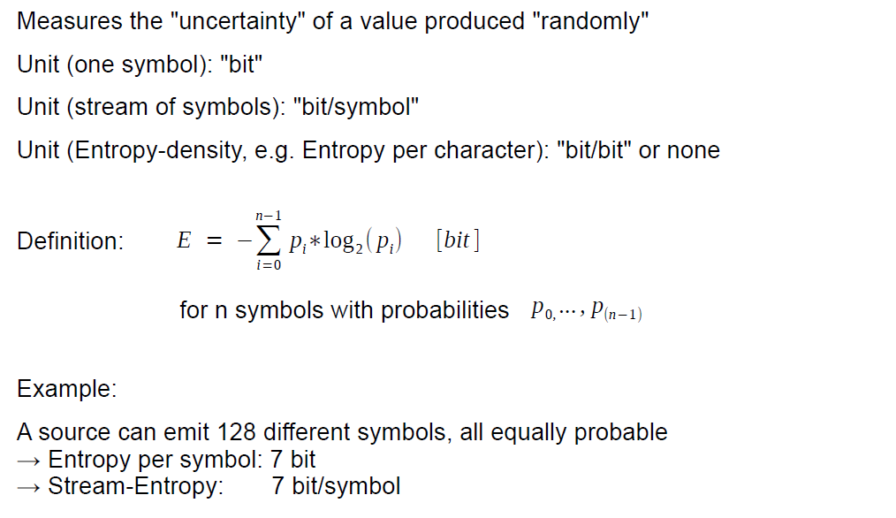

## Estimating Entropy is Tricky

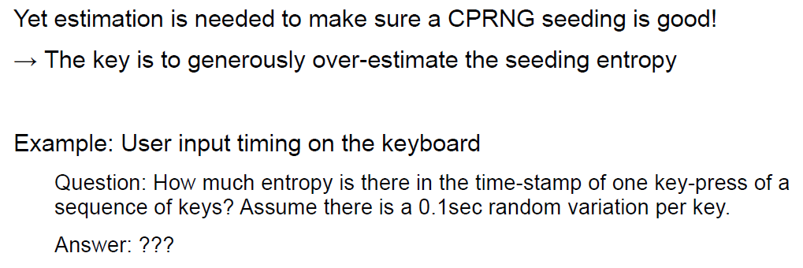

## Seeding a CPRNG

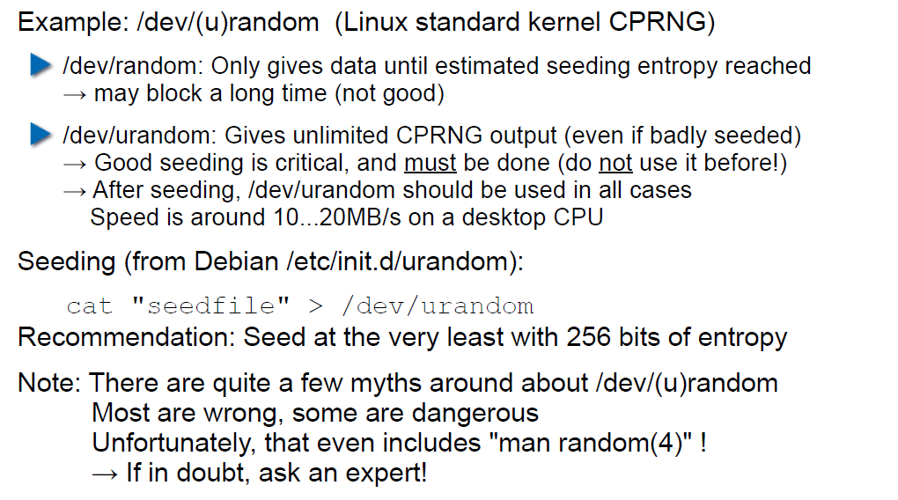

## Bad Seeding Examples

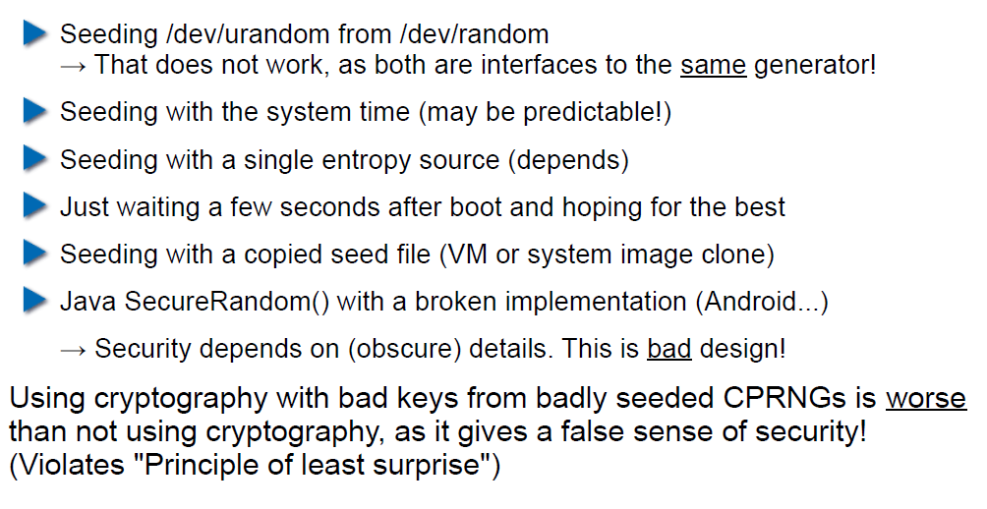

## Storing Cryptographic Keys Securely

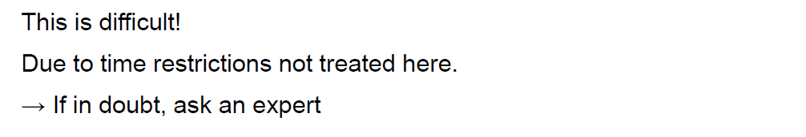

## Storing Passwords

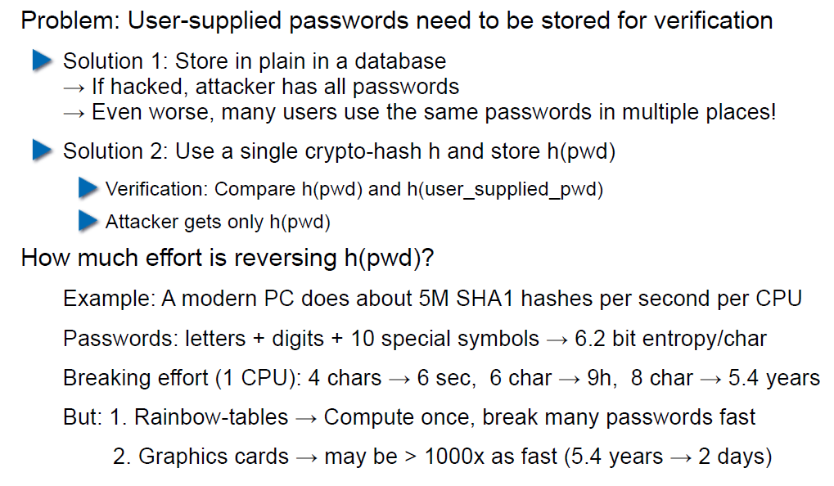

## Rainbow Table

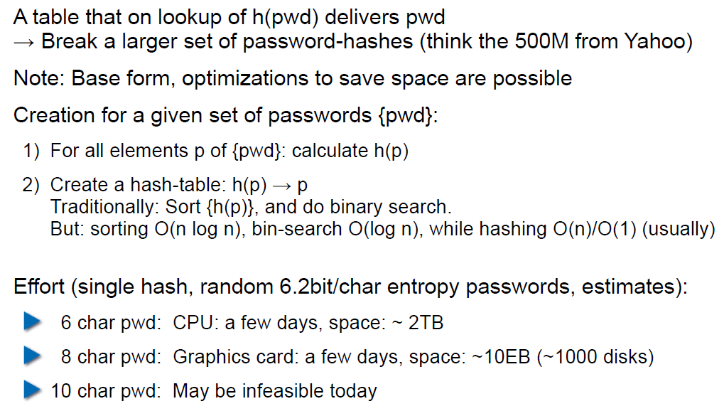

## Storing Passwords

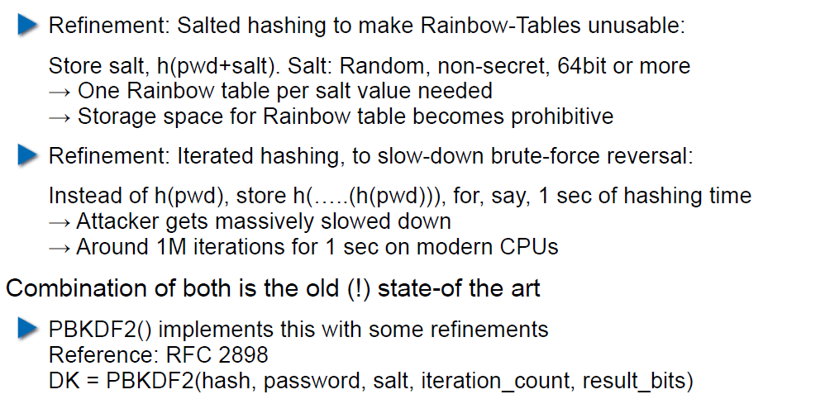

## So What is Wrong with PBKDF2?

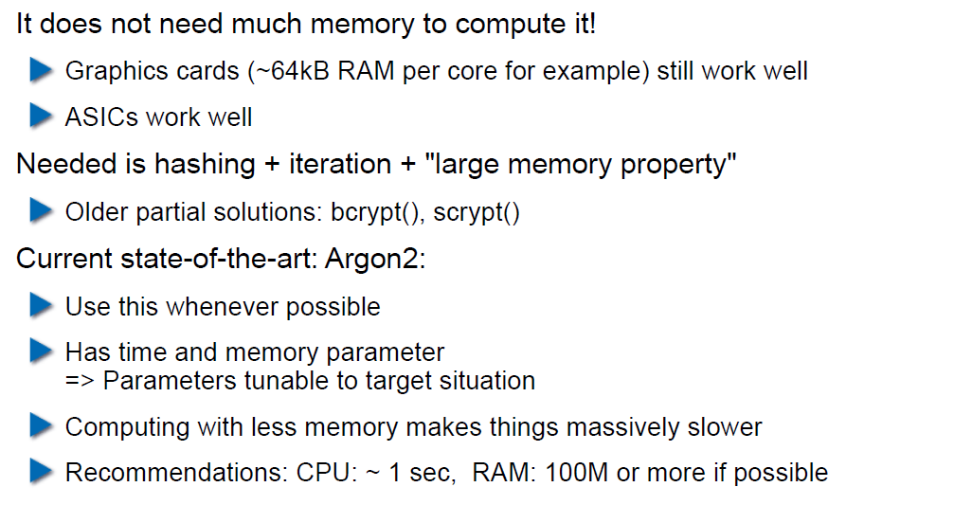

## Hardware RNGs

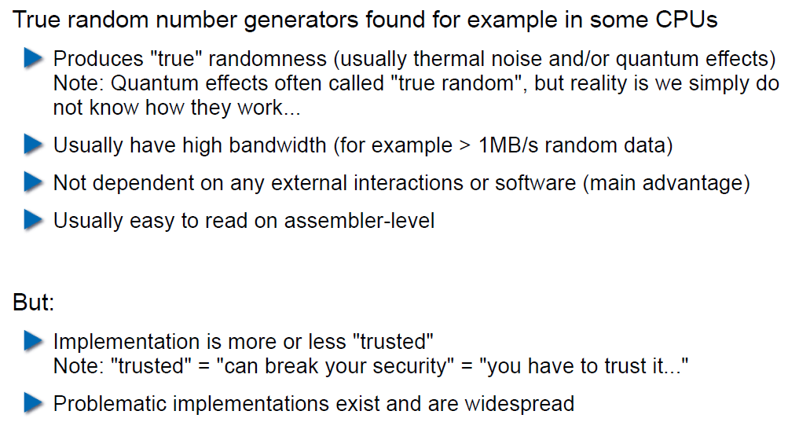

## Example 1: Via C3 Hardware CPRNG Schematic

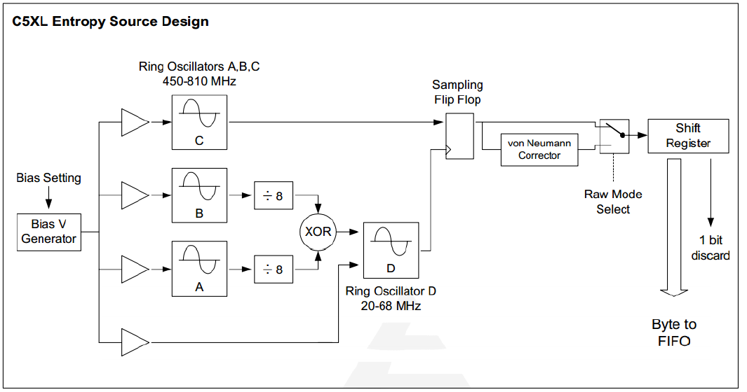

## Example 2: Intel RDRAND Schematic

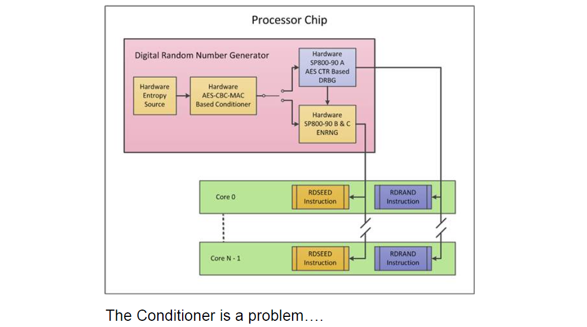

## Compromise on Design-Level

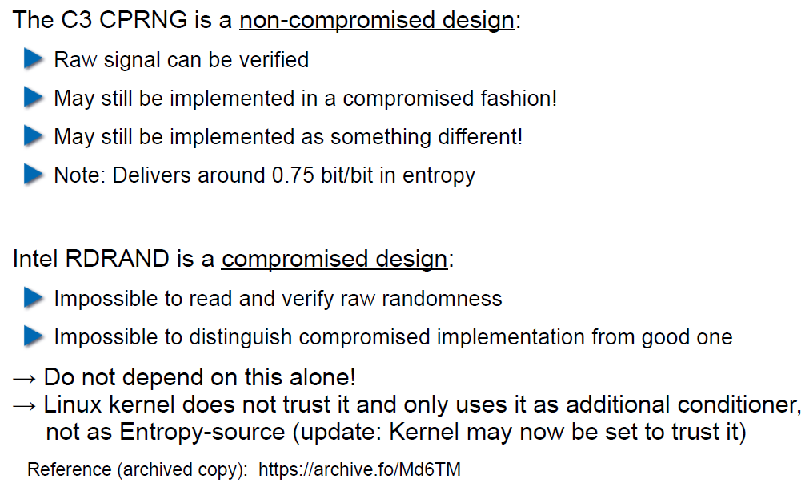

## Storing Private Data (as a Service Provider)

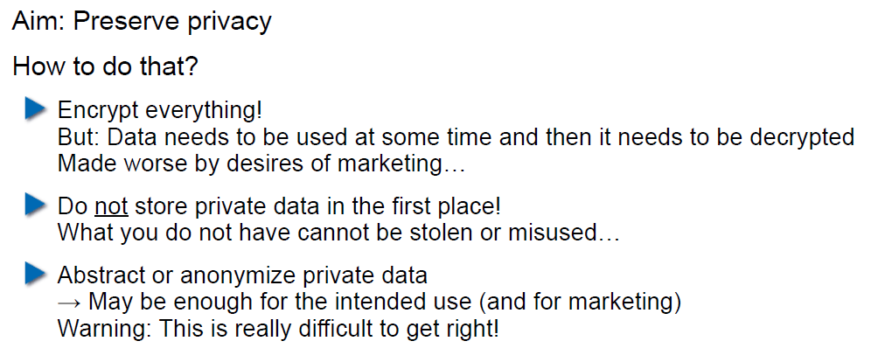

## Disk/Storage Encryption

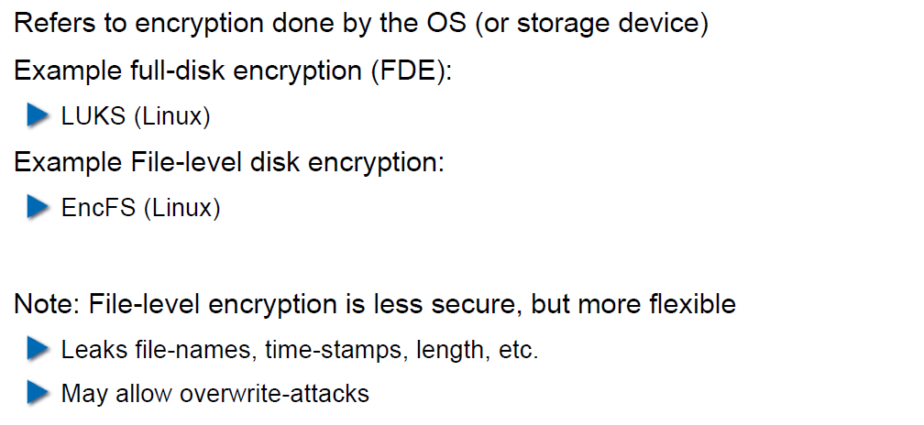

## Disk Encryption Protects Against What?

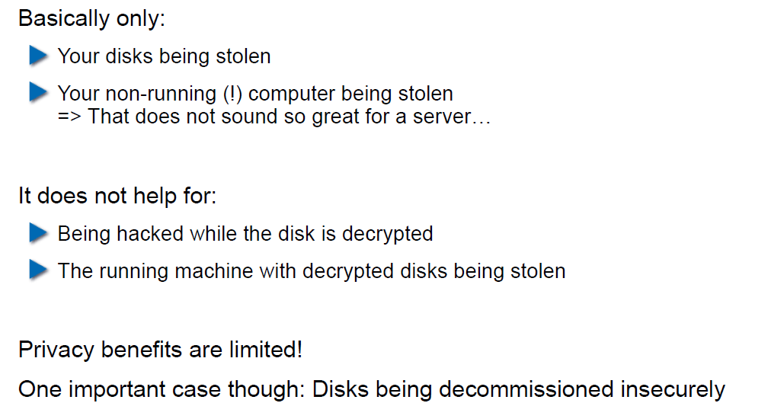

## Decryption Only With User Logged In

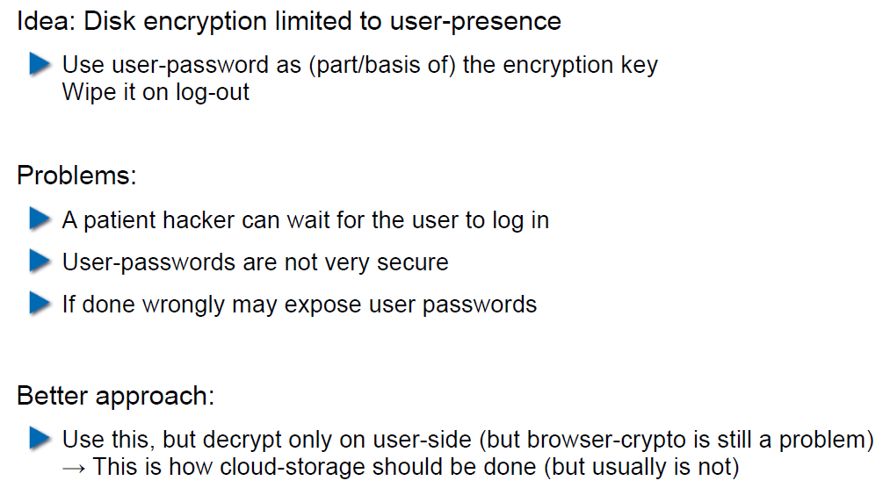

## Encryption in the Cloud

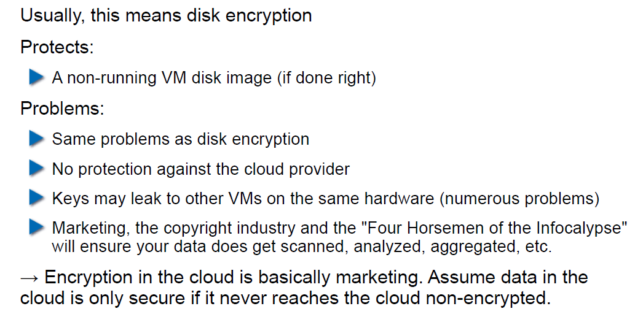

## JavaScript Client-Side Encryption in Web-Apps

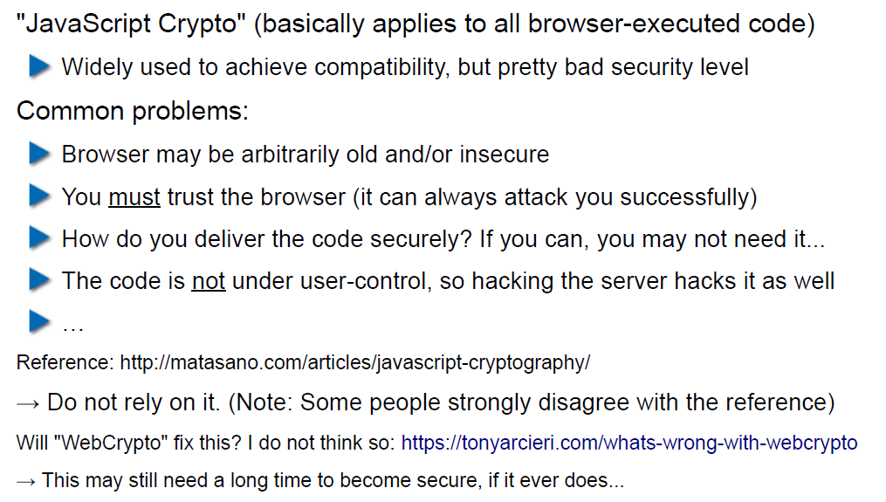

# Woche 6

## Agenda

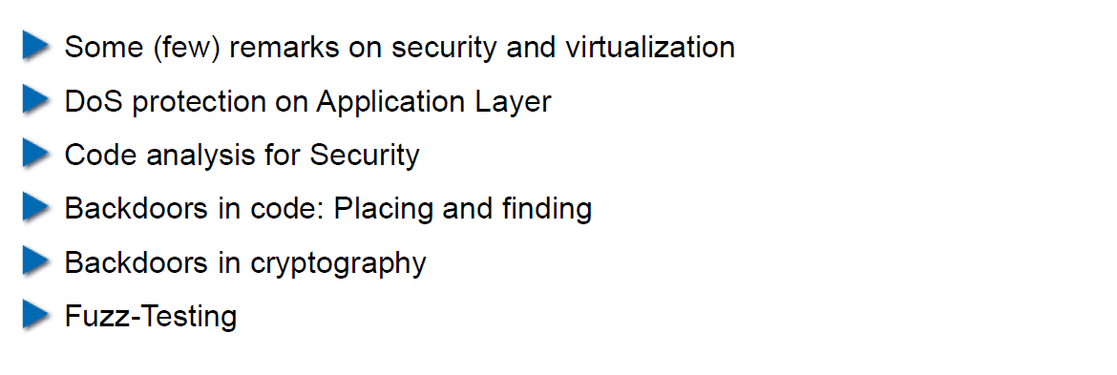

## Virtualization vs. Security

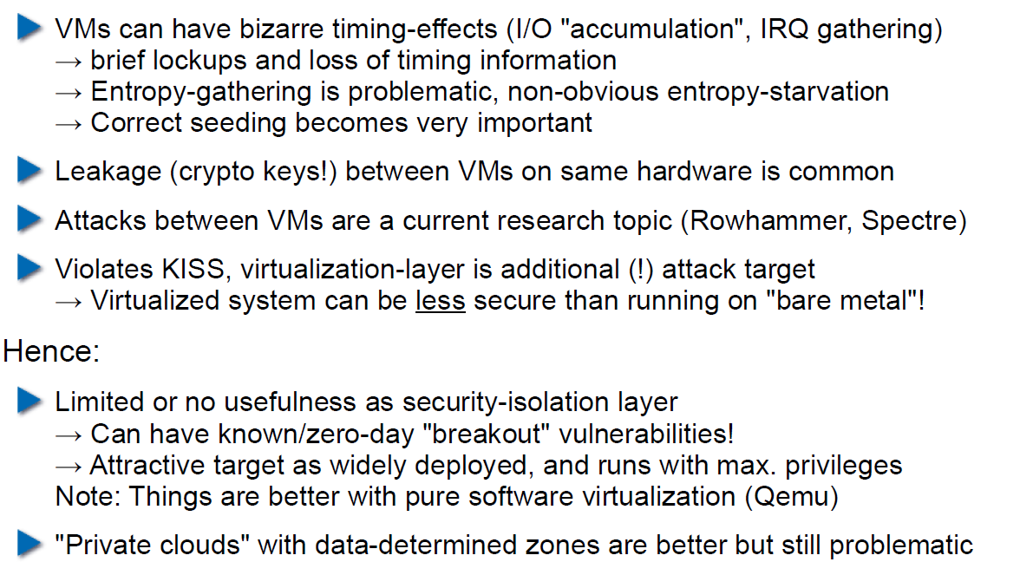

## DoS on Application Layer

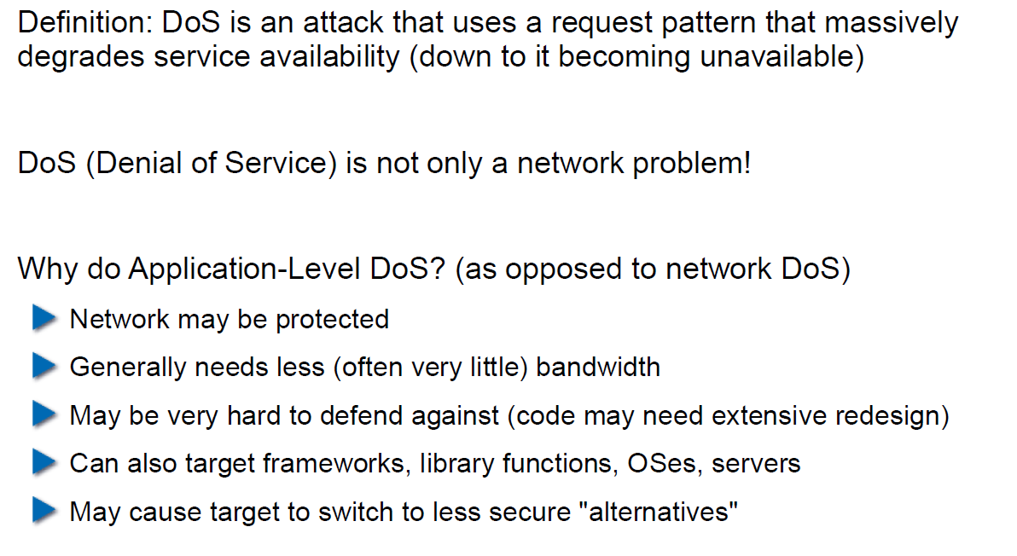

## DoS on Application Layer

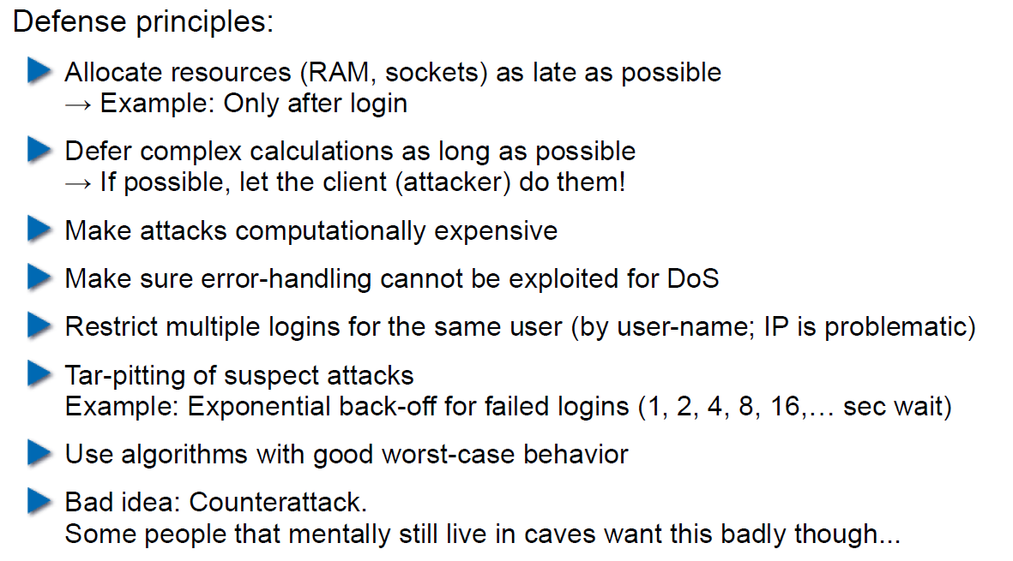

## Code Analysis for Security

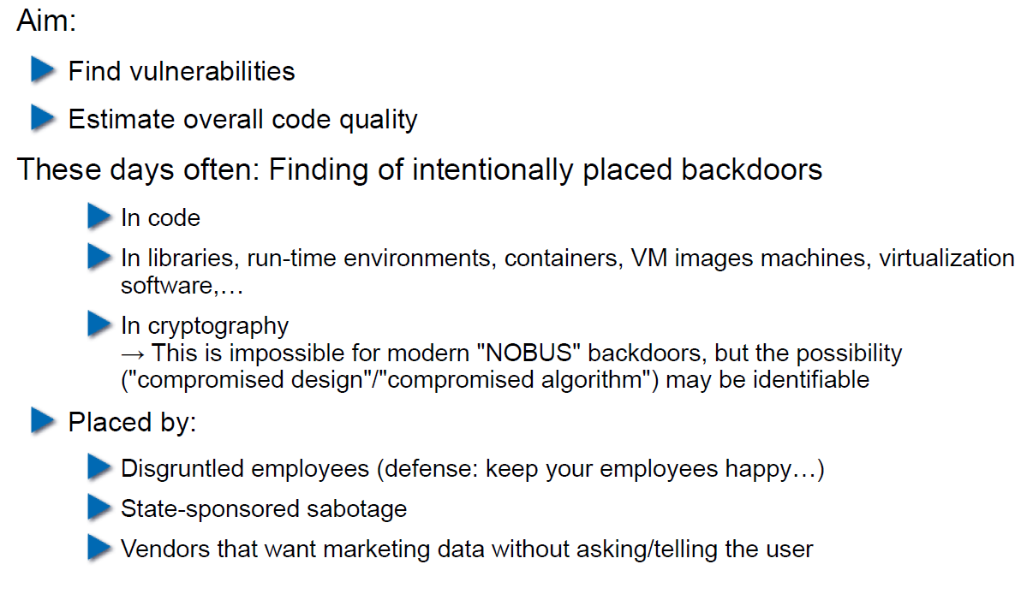

## Backdoors in Code

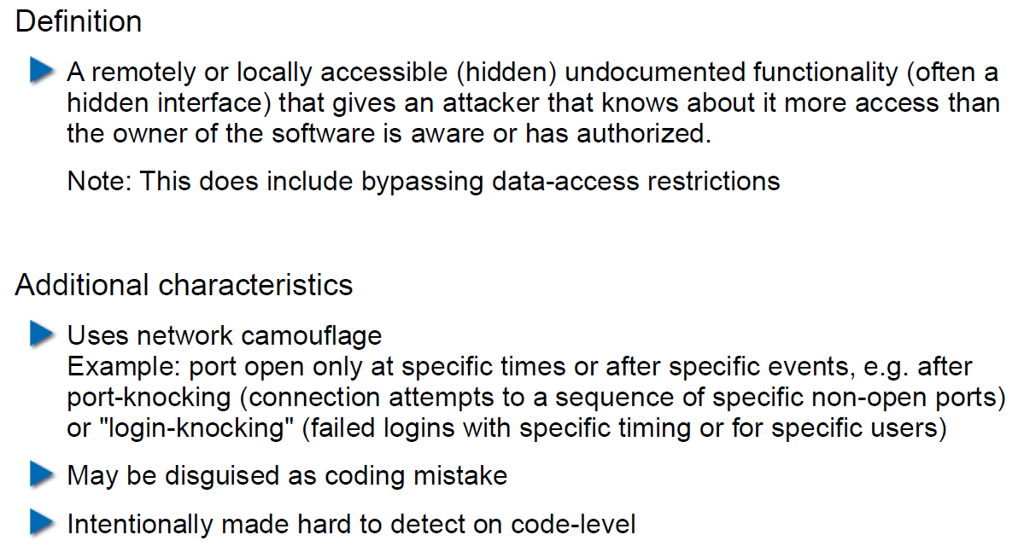

## Backdoor Hiding Techniques

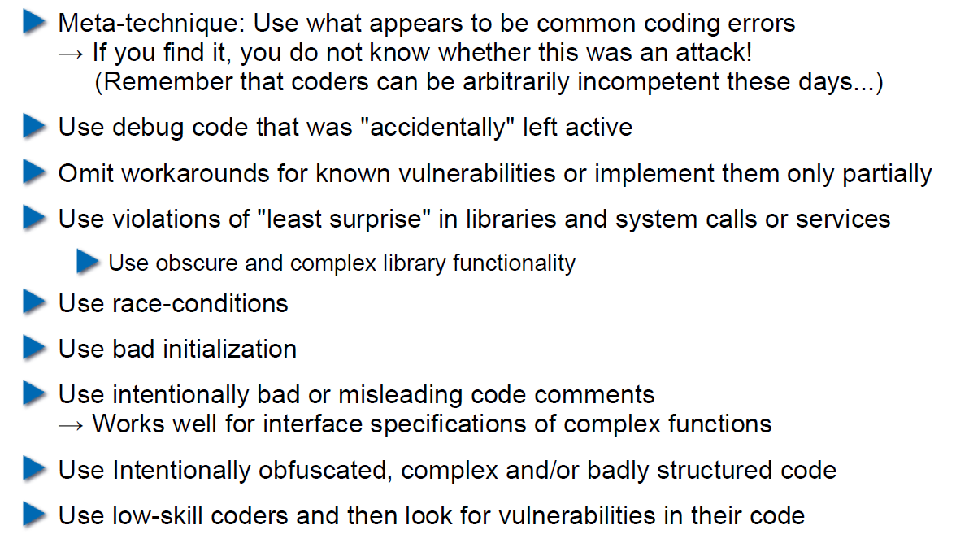

## Finding Backdoors

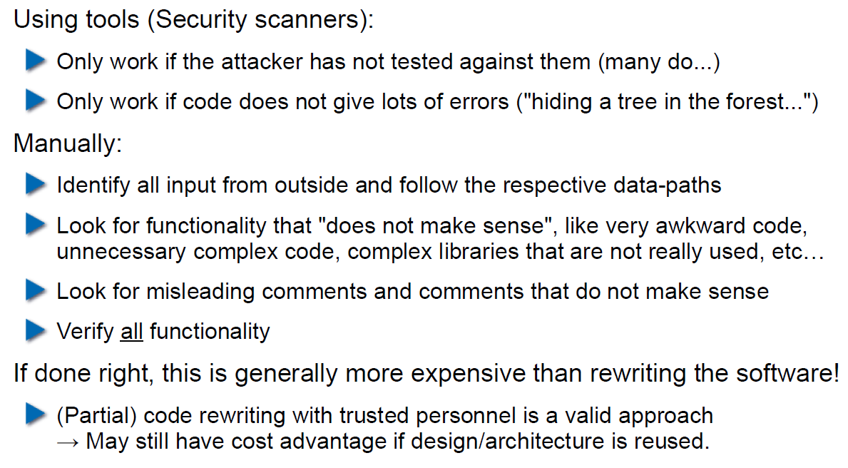

## Backdoors in Cryptography

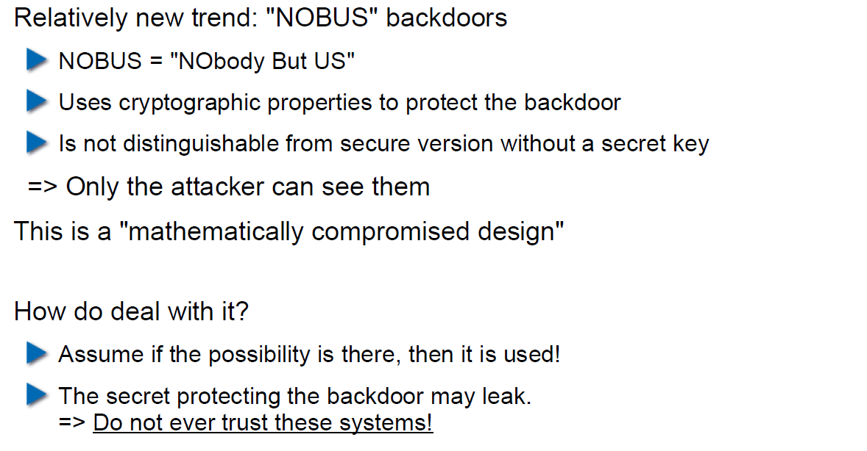

## Example 1: ECC

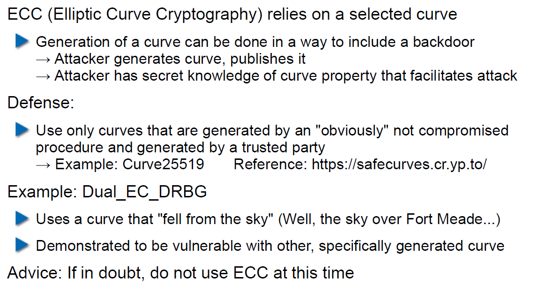

## Example 2: Specially selected Primes for Discreet Logarithms

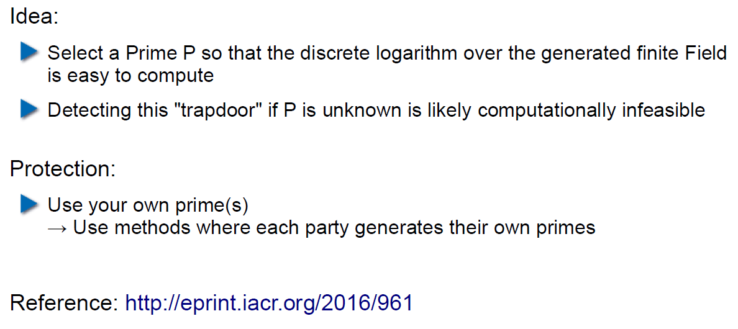

## Fuzz-Testing: The Idea

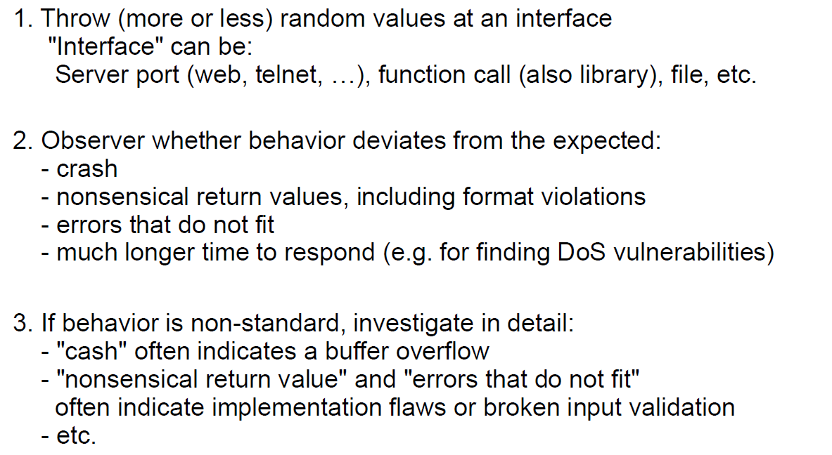

## Possibilities and Limitations

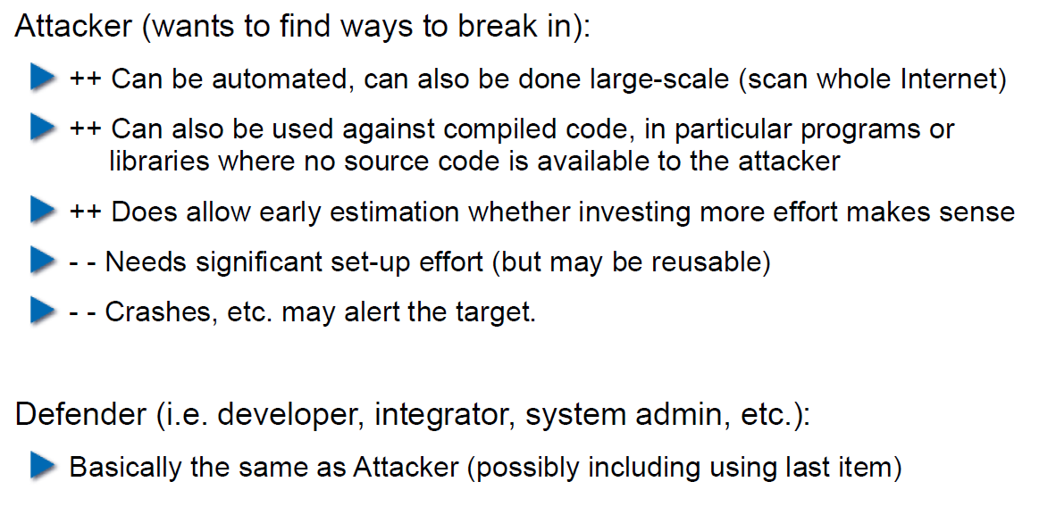

## Structured Fuzzing vs. Random Fuzzing

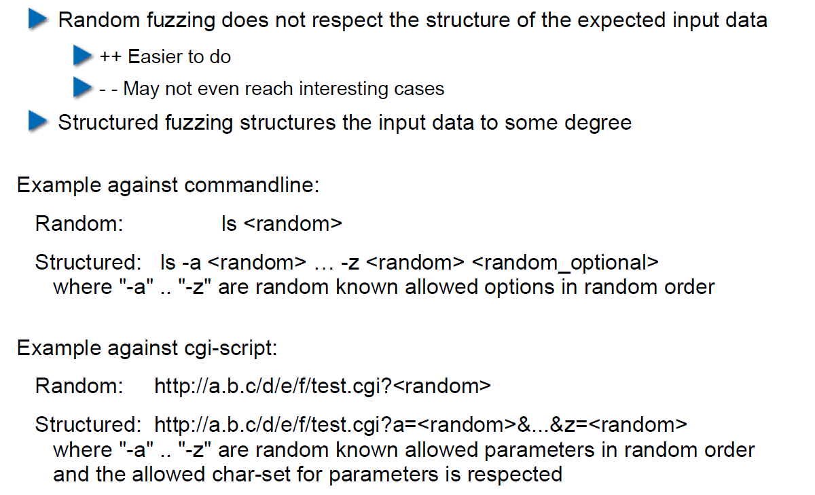

## Fuzzing for Regular Tests

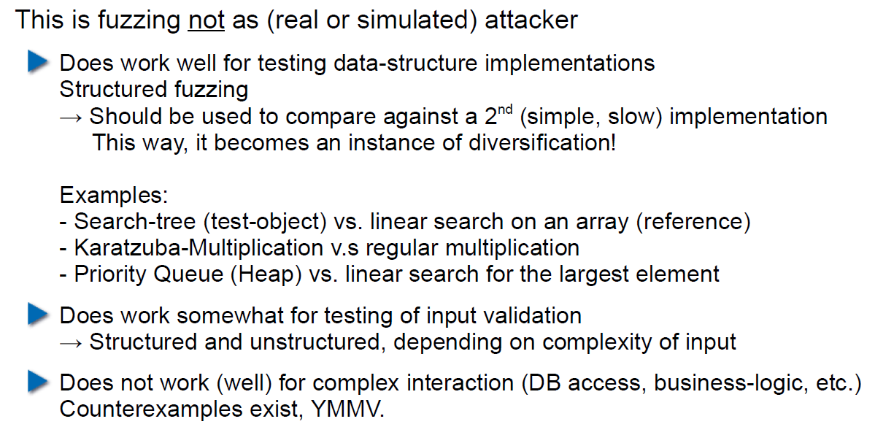

## Useful Fuzzing Tools

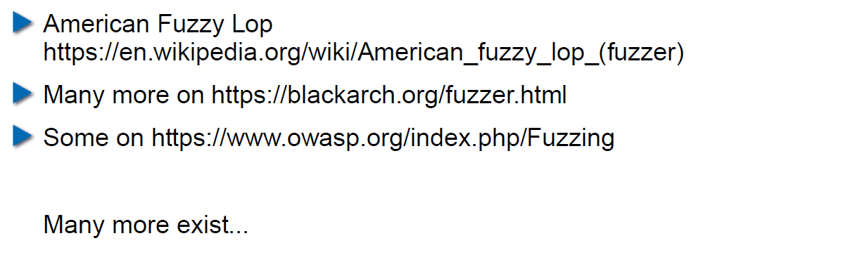

# Woche 7

## Agenda

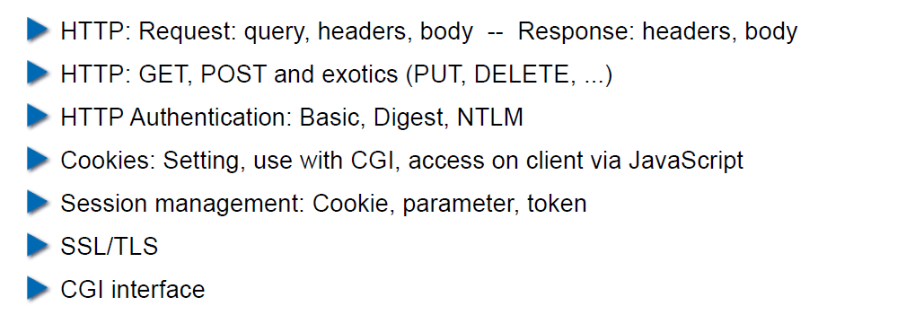

## Example Request in the TCP/IP Model

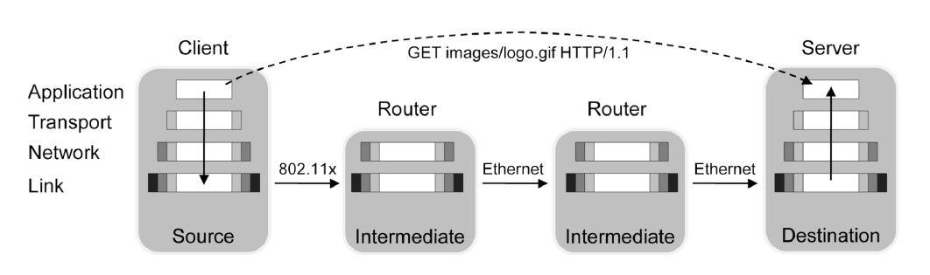

## HTTP

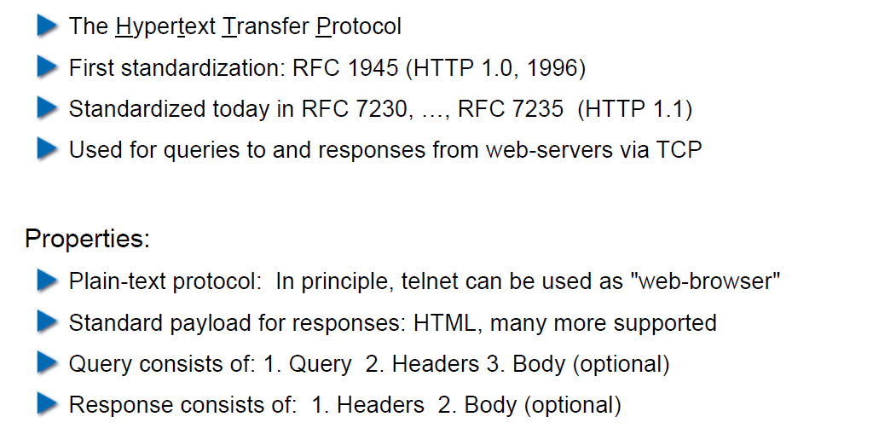

## HTTP Request Example: GET

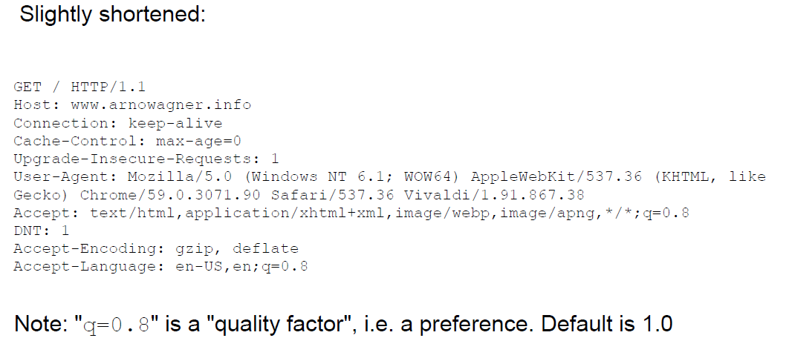

## HTTP Request Example: POST

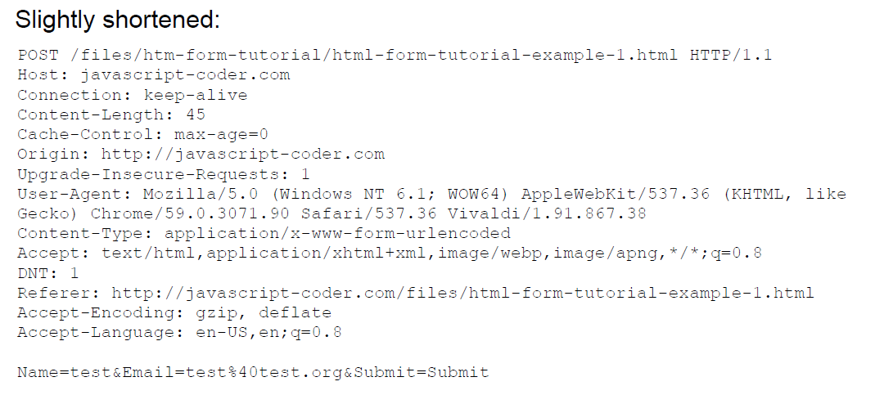

## HTTP Response Example

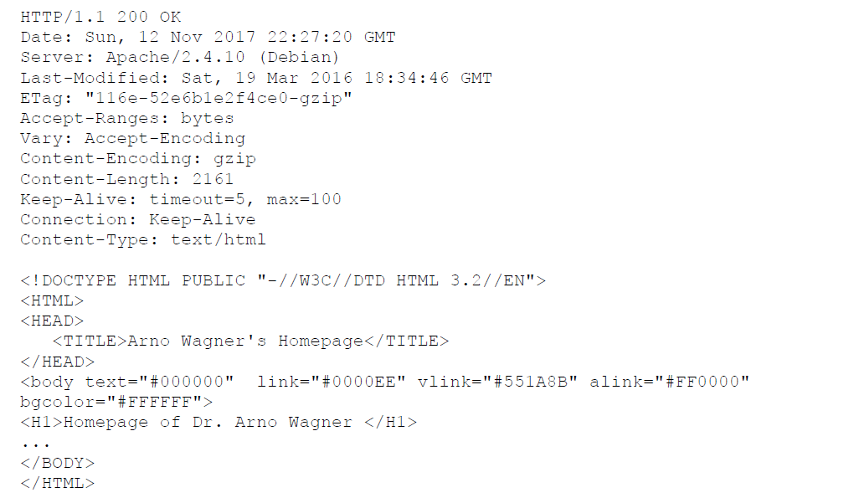

## Exotic Requests: PUT, DELETE, ...

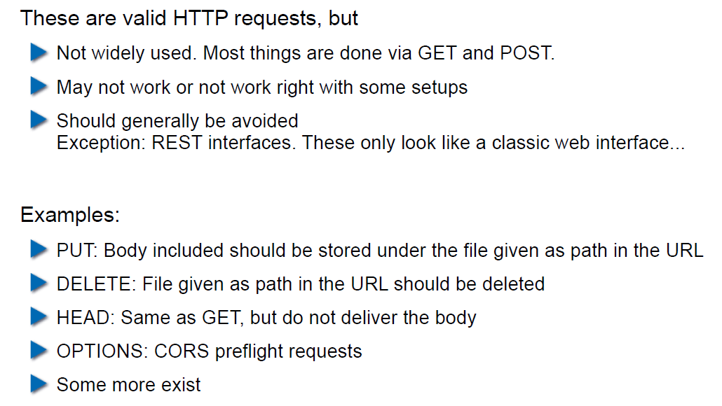

## HTTP Authentication

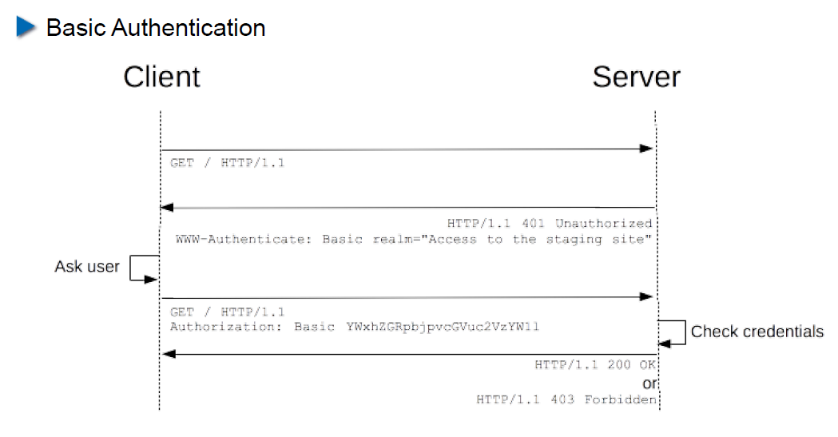

## HTTP Authentication

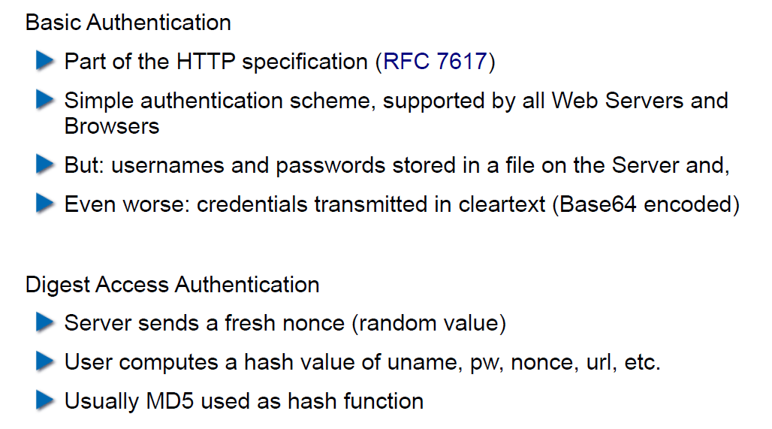

## Cookies

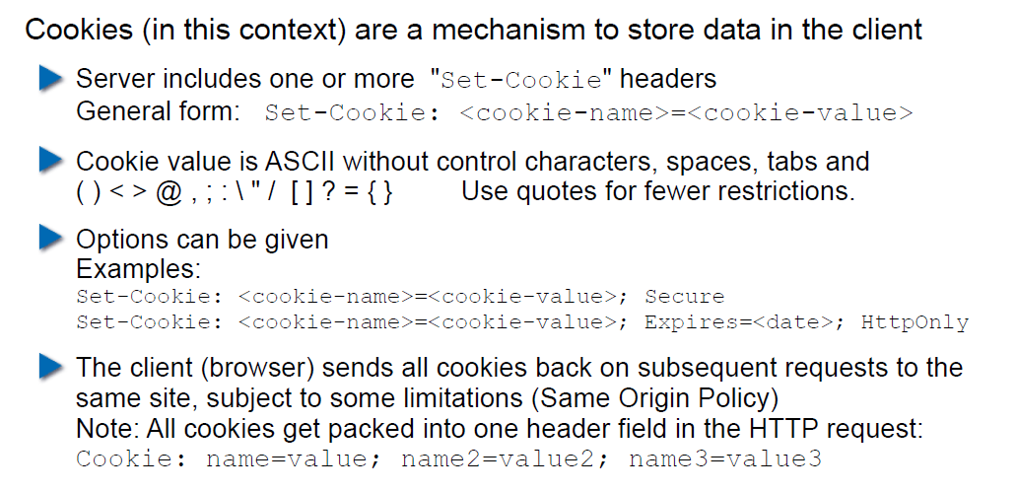

## Cookie Options

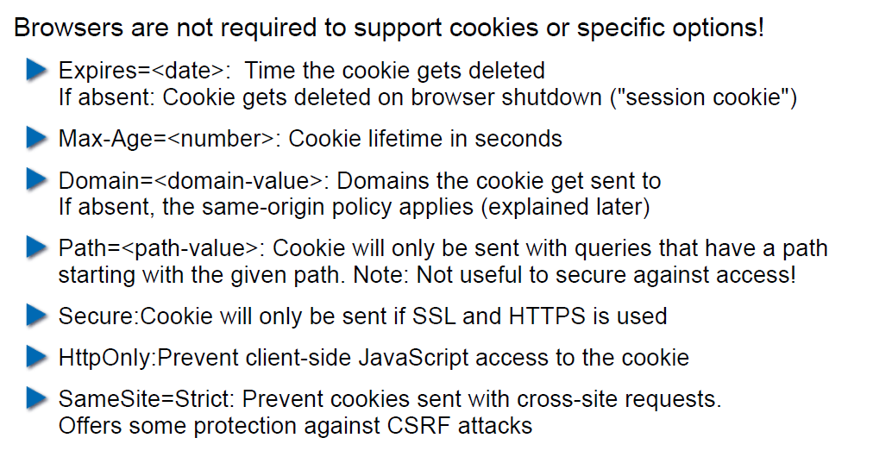

## Cookies: Access via JavaScript

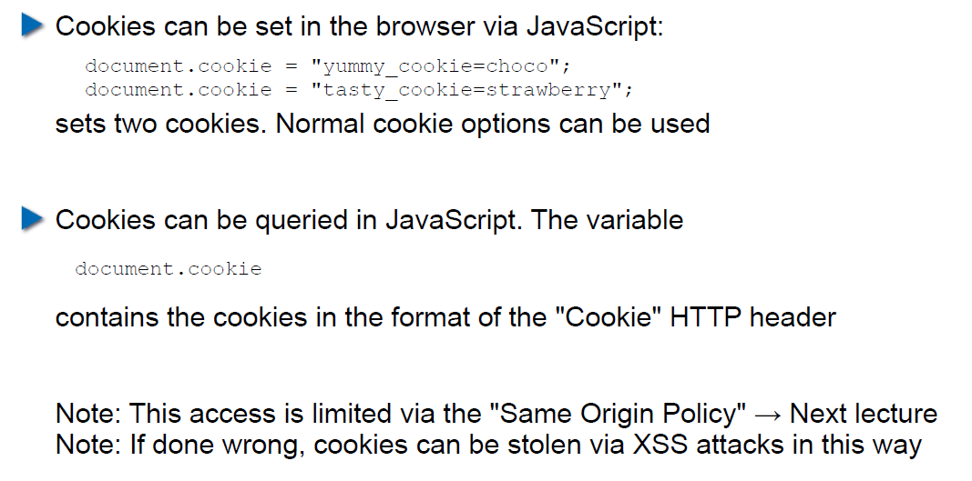

## Session Management

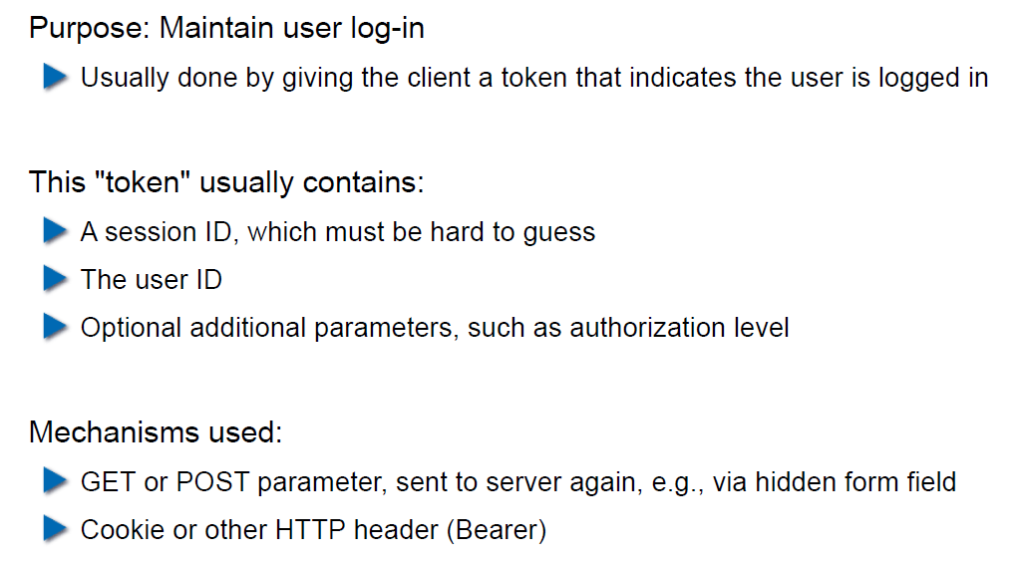

## Security Problems with Session Management

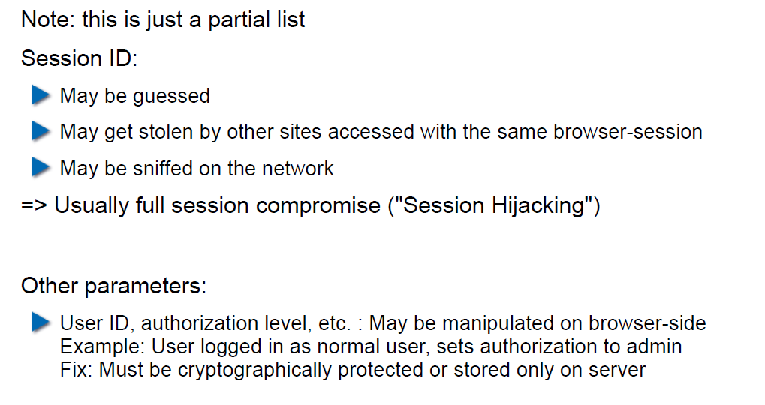

## Keeping State Securely on Client-Side

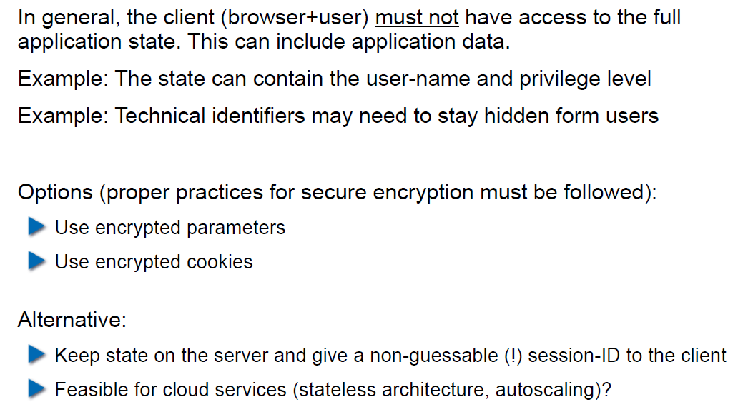

## Remark: Cookies and Application Paths vs. Proxies

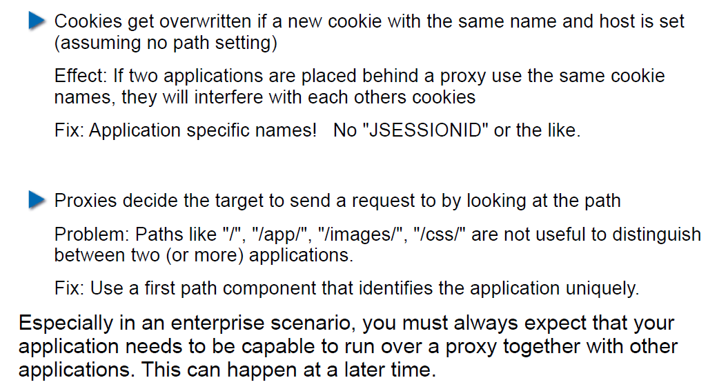

## SSL/TLS

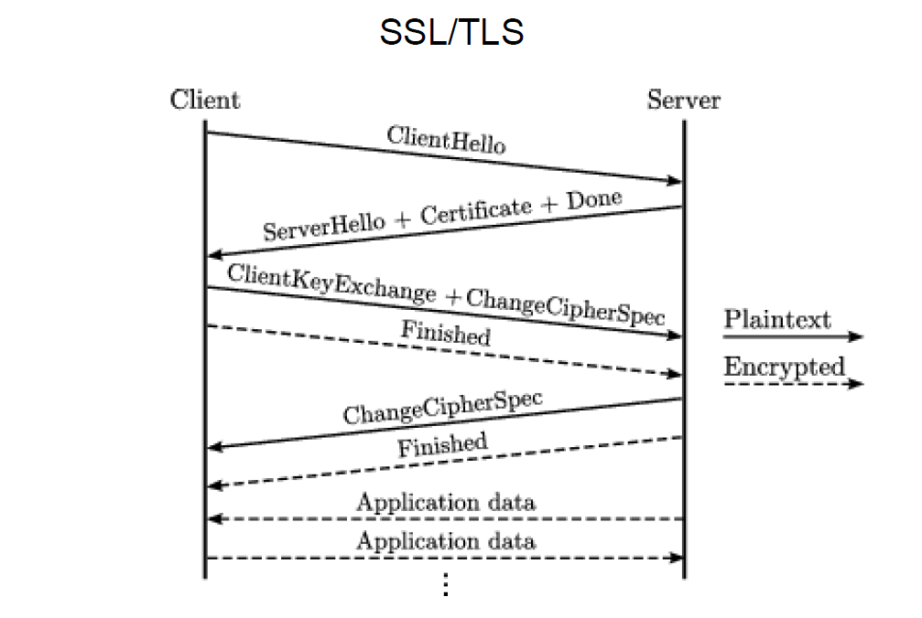

## SSL/TLS

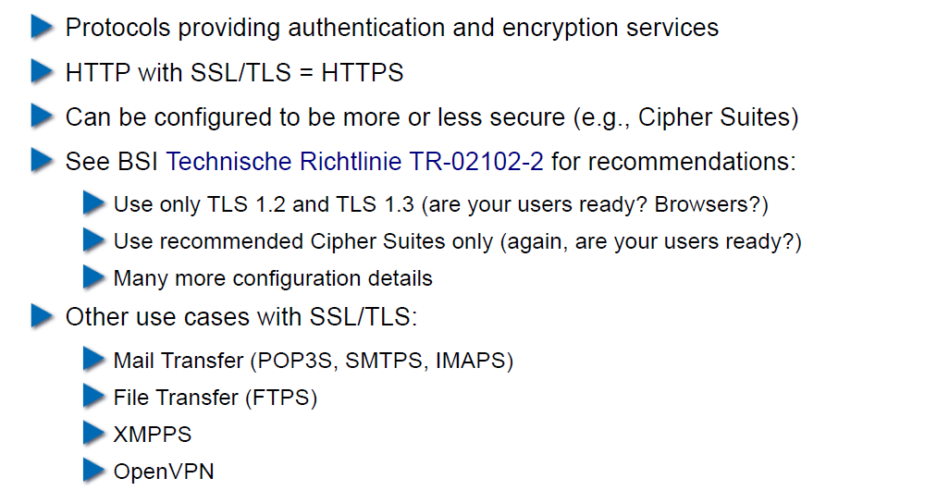

## CGI: General Idea

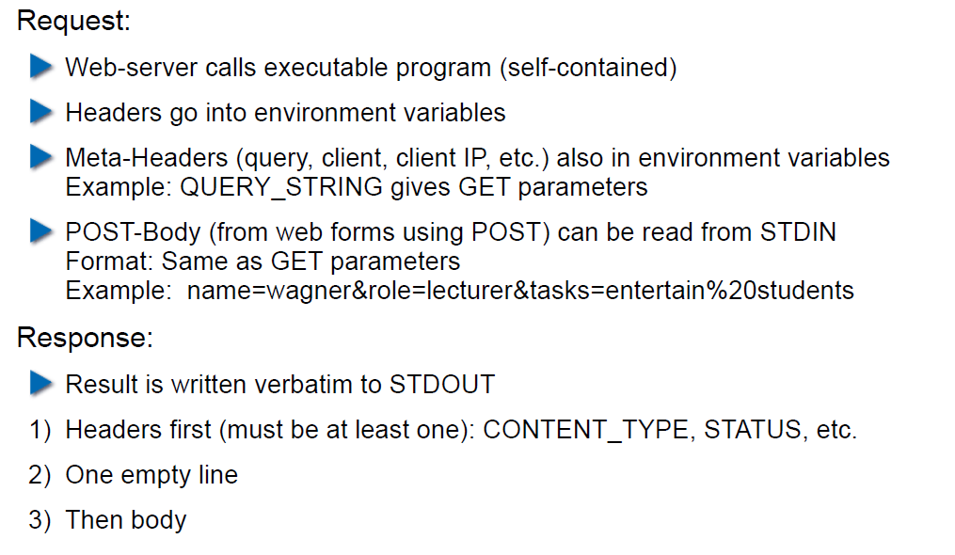

## CGI Scripts in Different Languages

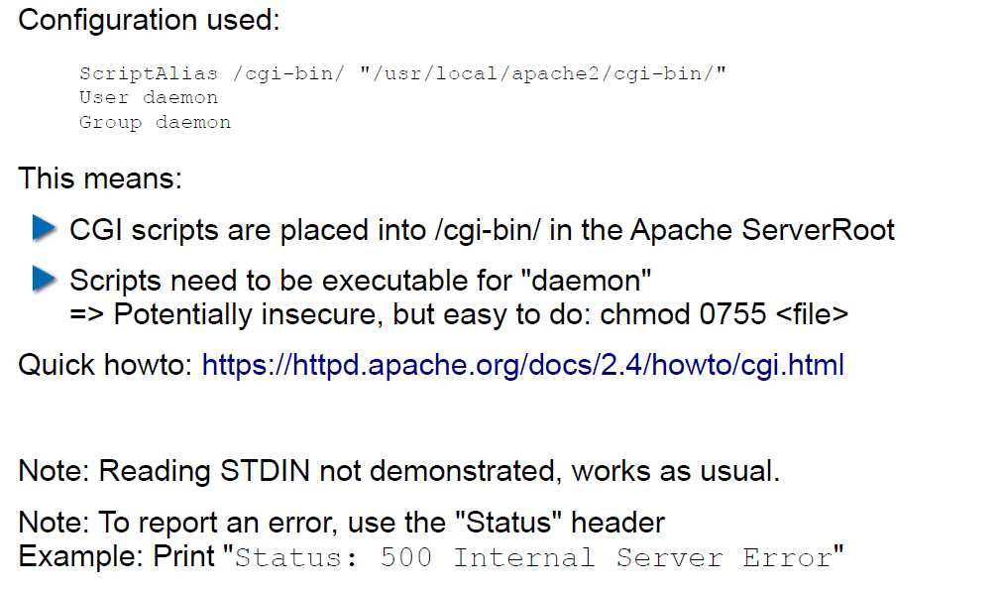

## CGI in BASH

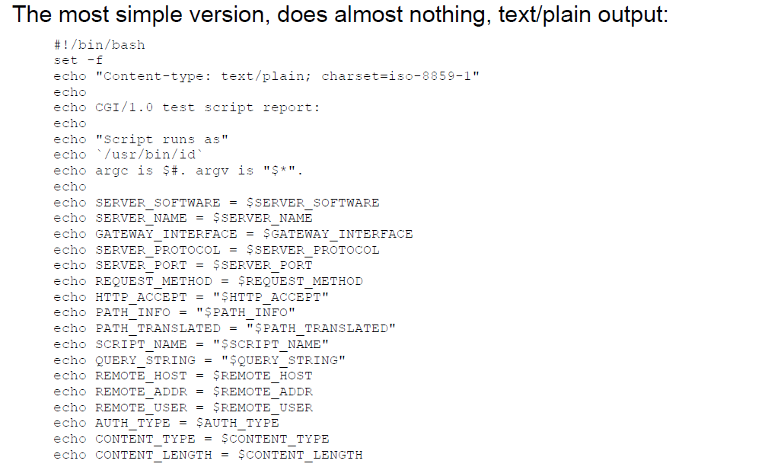

## CGI in BASH: Output

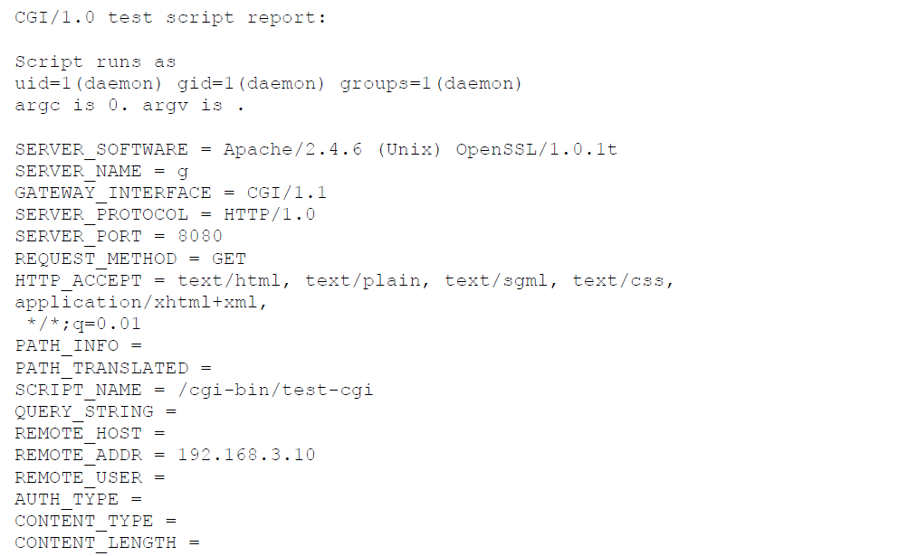

## CGI in Perl

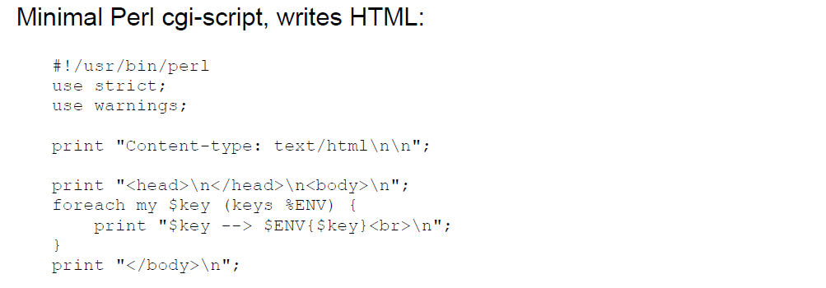

## CGI in Perl: Output

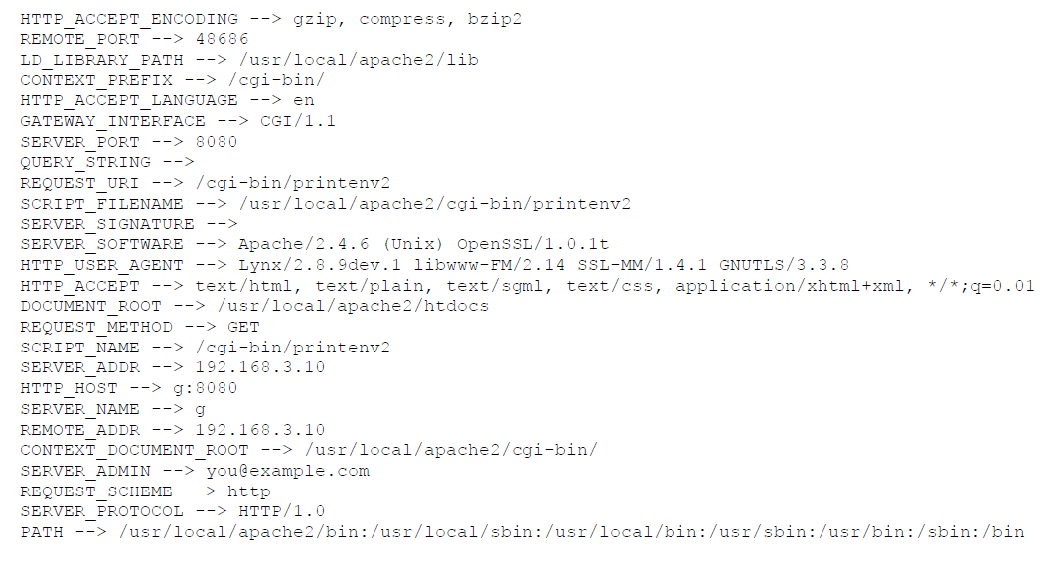

## CGI in C

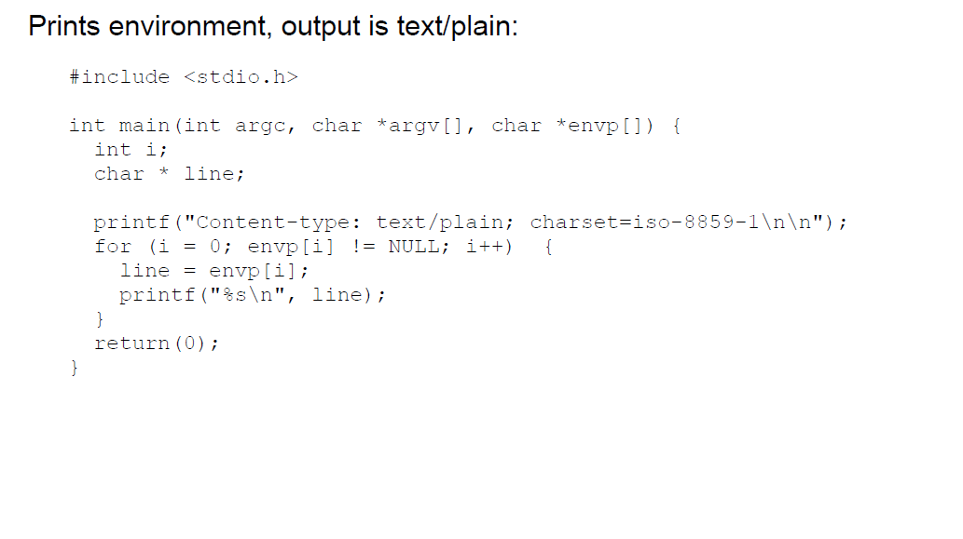

## CGI in C: Output

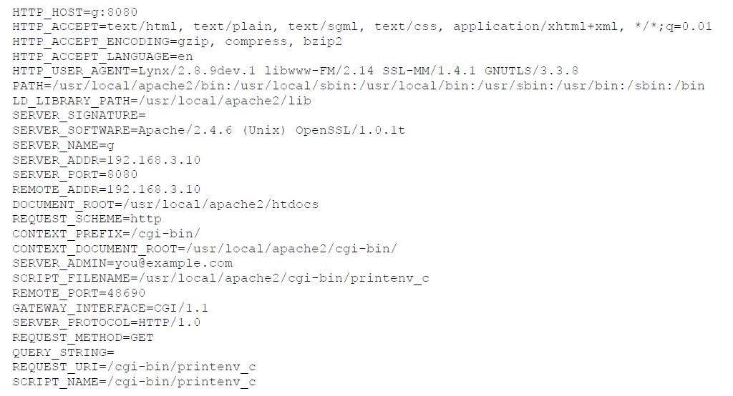

## CGI in Java

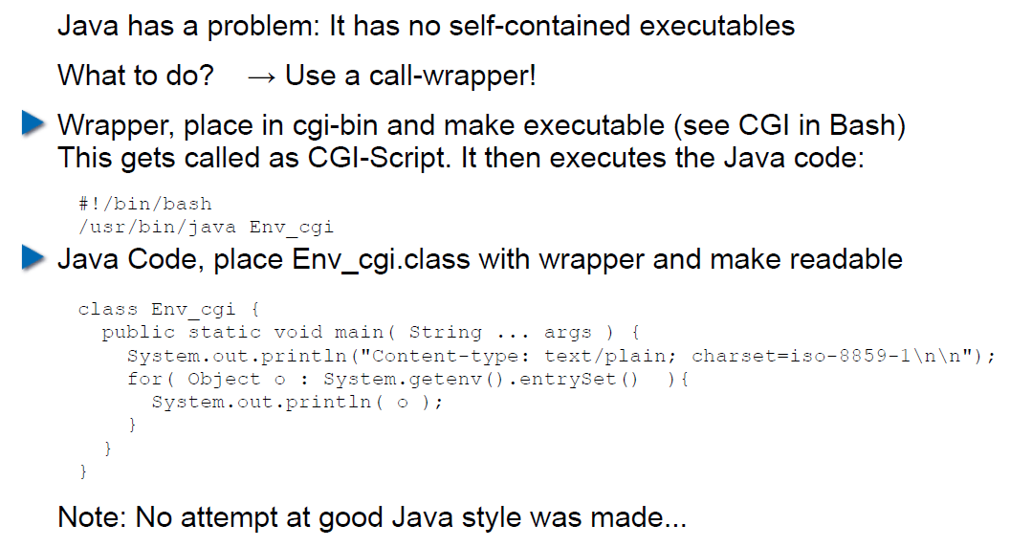

## CGI Security

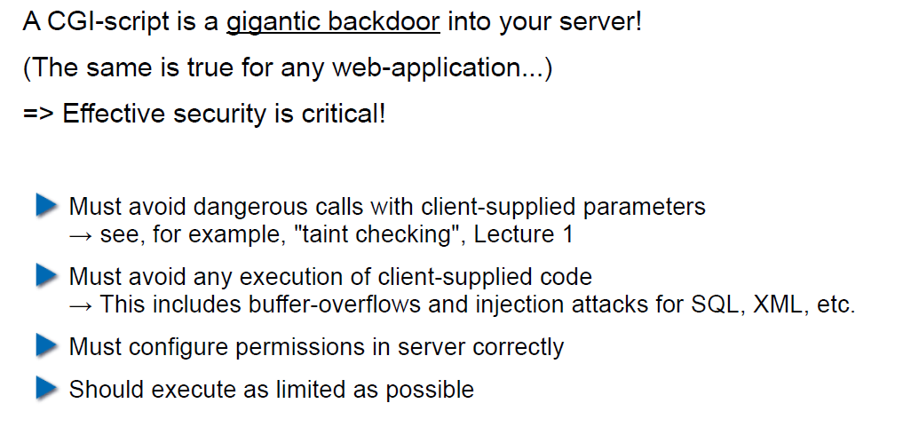

# Woche 8